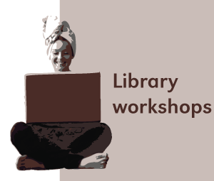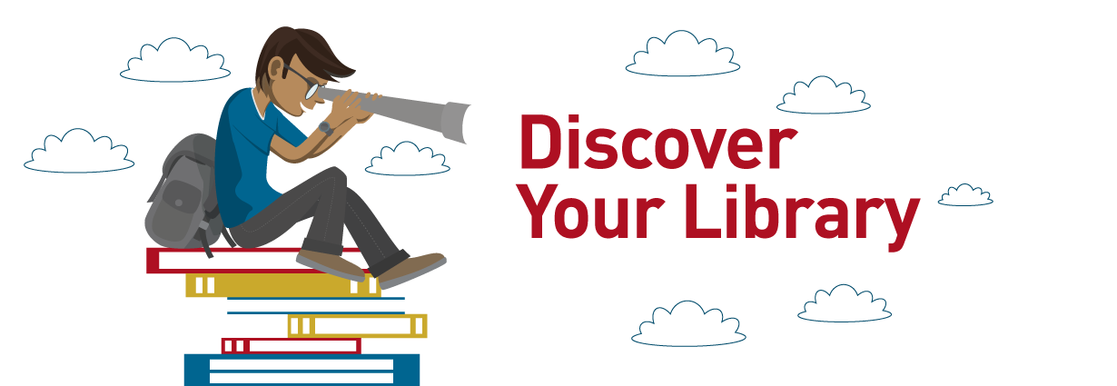

Library Workshops

Monday 20 February -08 March 2017
The Howard College Main Library is offering workshop to all students in the first semester. This training is mandatory to all First Year 2017 students. Workshop will cover how to search the Library search engine (Worldcat Local), and Referencing. Registration is free.
Sign up for a session in the foyer on the ground floor. Training sessions are held in the Training LAN, Main Library basement.

Library workshops: 20 February – 08 March 2017
Date | Training | Time
Monday 20 February | icat & Referencing | 08h40 – 09h25
Monday 20 February | icat & Referencing | 14h10 – 14h55
Tuesday 21 February | icat & Referencing | 08h40 – 09h25
Tuesday 21 February | icat & Referencing | 14h10 – 14h55
Wednesday 22 February | icat & Referencing | 08h40 – 09h25
Wednesday 22 February | icat & Referencing | 14h10 – 14h55
Thursday 23 February | icat & Referencing | 08h40 – 09h25
Thursday 23 February | icat & Referencing | 14h10 –14h55
Friday 24 February | icat & Referencing | 08h40 – 09h25
Friday 24 February | Icat & Google scholar | 14h10 – 14h55
Monday 27 February | icat & Google Scholar | 08h40 – 09h25
Monday 27 February | Icat & Google Scholar | 14h10 – 14h55
Tuesday 28 February | Icat & Google Scholar | 08h40 – 09h25
Tuesday 28 February | Icat & Google Scholar | 14h10 – 14h55
Wednesday 1 March | icat & Google Scholar | 08h40 – 09h25
Wednesday 1 March | Icat & Google Scholar | 14h10 –14h55
Thursday 2 March | Icat & Google scholar | 08h40 – 09h25
Thursday 2 March | Icat & Google scholar | 14h10 – 14h55
Friday 3 March | ICatalogue & Referencing | 08h40 – 09h25
Friday 3 March | ICatalogue & Referencing | 14h10 – 14h55
Monday 6 March | ICatalogue & Referencing | 08h40 – 09h25
Monday 6 March | ICatalogue & Referencing | 14h10 – 14h55
Tuesday 7 March | ICatalogue & Referencing | 08h40 – 09h25
Tuesday 7 March | ICatalogue & Referencing | 14h10 –14h55
Wednesday 8 March | ICatalogue & Referencing | 08h40 – 09h25
Wednesday 8 March | ICatalogue & Referencing | 14h10-14h55

