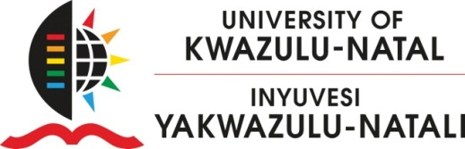

MASTERING THE MASTERS PROGRAMME
COLLEGE OF AGRICULTURE, ENGINEERING & SCIENCE
25 June, 2015

Dear All,

RE: ACADEMIC WRITING COMPETENCE FOR PUBLISHING
Academic writing style is not explicitly taught at any level, which can result in many academic professionals experiencing difficulties in publishing research articles. The Mastering the Masters Programme will be running workshops on advanced academic writing competence workshops during the winter break (6th – 10th July PMB and 13th – 17th July Durban) for Academic staff and PhD students who have a manuscript they are currently working on for publishing. So please bring your own writing to the workshop as this is the only way the process will assist you.

The writing for publication workshop will be an opportunity to:
- improve writing competence for paper publishing
- understand the underpinnings of academic writing (nominalisation)
- be trained to self-edit and peer-edit academic articles/dissertations
- generate a self-edited document for publication
- acquire skills to write future academic articles with confidence

The process will involve an initial session which provides an overview of the academic writing genre to orientate one towards the requirements of this particular writing. The main objective is to focus on developing advanced writing skills for your manuscript by addressing the following writing competences:
- Socio-cultural competence: the purpose, participants and context
- Linguistic competence: sentence construction and nominalization (packing in information in
noun groups, thereby introducing several ideas in one sentence. It is effective in academic writing as it reduces redundancy).
- Structural competence: coherence, cohesion, paragraphing and logical order of sections and
sub-sections
- Process competence: the planning and writing process, but especially self and peer editing.
As you acquire these competences you will be shifting your writing from informal to the formal writing required in an academic setting.
This session is followed by mentorship sessions in academic writing. Participants will be split into smaller groups of three to four individuals in the same (or close) area of interest. These smaller groups will be mentored to be able to identify individuals’ own patterns of error so as to self-edit their own documents, and as they work with others in this small group, they will also learn to peer-edit. The mentorship is better than sending out your document for editing, in that the context and meaning of the writing is not lost as compared to when someone who is not in that field does the editing. This practical and interactive writing process in groups also assists individuals in developing their confidence in writing.
VENUES:
PMB: Room PG 35, No. 1 Golf Road, Pietermaritzburg Campus
WESTVILLE AND HOWARD: Seminar Room 3 & 4, Biology Building, Westville Campus

Please RSVP to Bernie Smith at smithb@ukzn.ac.za ext. 6473 by 1st July, 2015.

Regards,
Fortune Shonhiwa (Coordinator – Mastering the Masters Programme)
College of Agriculture, Engineering and Science

