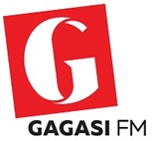
The Incubator Hub - Selection Criteria 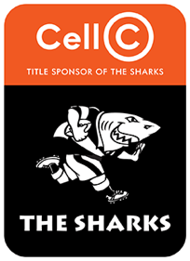

The Incubator Hub will seek to afford a limited number of graduates the opportunity to gain work experience whilst earning a stipend. The Hub will initially align itself with MAC charter, therefore the areas focused on will be Marketing, Advertising and Communication.

Applications are invited from interested applicants in possession of a relevant three (3) year degree or National Diploma in the areas of marketing, advertising or communications gained from a recognised University or University of Technology. The programme will take 6 graduates per annum for a period of 12 months.

Direction to applicants:
A motivational application should be submitted by interested parties. The proposal should highlight why the incumbent should be considered for this opportunity and should not exceed 500 words.

In addition, Certified copies of the following documents must also be submitted (not older than 3 months):
- South African identity document
- Degree/diploma certificate and Matric or senior certificate
- Full academic record indicating individual modules or courses

NB: Those who have studied at Private Higher Institutions are also directed to provide a Credit Certificate indicating the number of credits the qualification has.

If any of the documents mentioned above are not attached, the applicant will not be considered. The Incubator Hub reserves the right to place or not place applicants based on its needs and requirements. The closing date for application is 31 March 2019.

In addition, applicants must be/have:
- Curriculum Vitae
- South African Citizen
- Reside in KZN
- Unemployed graduate between the ages of 18-35
- Prepared to enter into a contractual agreement with The Incubator Hub

Interested applicants should forward their applications to the following address: info@bluedoortheory.co.za

