DALE MARGARET HASLOP

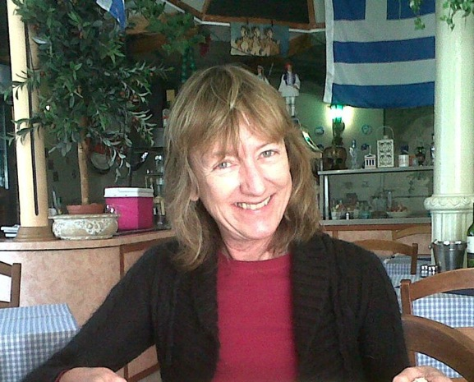

Dale Haslop recently passed away after a short illness. Dale had recently retired from the School of Mathematics, Statistics and Computer Science at the University of KwaZulu-Natal with almost 30 years of continuous service. In her position as School Secretary on the Howard College Campus she was recognized and accepted as a mother figure by students, staff and research visitors. She was the person to approach in moments of crisis and would assist in every way possible. It is largely for this reason that she will be greatly missed by us.

Our overseas research visitors remember her with fondness and recall her assistance with gratitude. Professor Naresh Dadhich of the Inter-University Centre for Astronomy and Astrophysics in Pune, India, said:
“She was a charming and very helpful friend of us all. We will miss her very much”
Dale came from the old school background of a strong work ethic and worked quietly in ensuring that deadlines were met and crises averted. Dale could always be counted on to see an assignment through – whether it was ensuring the examinations process proceeded without hitches, rescuing errant academic staff members from difficult situations, making last-minute travel arrangements, coming to work during weekends to capture data, or simply to assist with internal processes. Her’s was a long and distinguished service to the School and the University.

Her funeral was held on Friday 22 August at the Catholic Church in Maurice Nichols Road, Pinetown. The School of Mathematics, Statistics and Computer Science will be holding a memorial service on the Howard College Campus from 12:15pm to 13:15pm on Wednesday 3 September 2014 in the Howard College Theatre.

