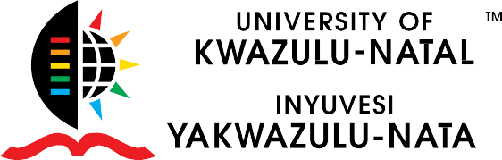

Invitation to WORLD AIDS DAY COMMEMMORATION EVENT
Dear Colleagues and Students
The University of KwaZulu-Natal HIV/AIDS Programme will be hosting the annual World AIDS Day event with the theme: “KNOW YOUR STATUS” underpinned to the
UNAIDS 90 90 90 targets.
The aim is to unite in the fight against HIV & AIDS. To commemorate those who have lost their lives due to HIV & AIDS related deaths. To support People Living with and affected by HIV & AIDS (PLWHIV); and to promote the
“KNOW YOUR STATUS” culture.

The event takes place as follows: DATE
Friday, 30 November 2018

TIME
10:00 – 13:00

VENUE
Howard College Library – HIV Museum
Click here to RSVP

This event marks a milestone of the institutional response to the pandemic. Especially in light of the new national strategies; UNAIDS 909090 targets, HTS Policy 2016, UTT 2016 and NSP 2017 to 2022. This opportunity will allow us to share an institutional response to HIV/AIDS.

We would like to invite you to join us on this auspicious event.
Your participation in the programme will be valued.
“Come and have Health screening and enjoy Honey bee’s massage”

Your presence would be highly appreciated
Refreshments will be served

