ATTENTION  STUDENTS IN THE COLLEGE OF LAW & mANAGEMENT STUDIES  UP YOUR GAME!  GET BACK ON THE GREEN  sTUDENT SUPPORT SERVICES ARE HOSTING STUDY SKILLS WORKSHOPS TO HELP YOU ACHIEVE THE MOST OUT OF YOUR STUDIES  SEE PANEL FOR DETAILS  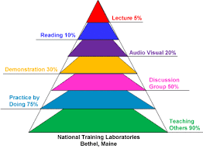  To RSVP, simply copy and paste in your browser:  https://docs.google.com/forms/d/e/1FAIpQLSc87abwnsFRvbgD_iOntxU2PWi8ppk5ap53RKzA-1trG9nKAQ/viewform | UPCOMING WORKSHOPS IN AUGUST 2017  ────  Time management  23 AUGUST  L1 –WESTVILLE CAMPUS  10.30am to12.00 pm  Learning styles & Study skills  30 AUGUST  L1- WESTVILLE CAMPUS  10.30 to 12.00pm  for MORE INFO CONTACT STUDENT support SERVICES on: 0312607337  or visit US AT  L-BLOCK  LEVEL 3

