Westville Campus Library
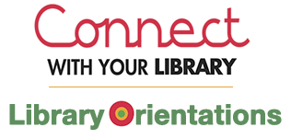
Library Orientation, you will learn:
- How the Library can help you, find information
- How to find books, videos, CDs and more in the Library's collection
- How to search for articles from magazines, journals and newspapers
- How to use the Library's resources (Printing. Etc.)

Date: 04 – 15 Feb.2019
Venue: Training LAN (Level 3) room B119 (Westville)
Times: Time: 1st session 10:30am / 2nd session 11:30
Contact: Roy Dorasamy dorasamym@ukzn.ac.za
Tel: 031 2607453

