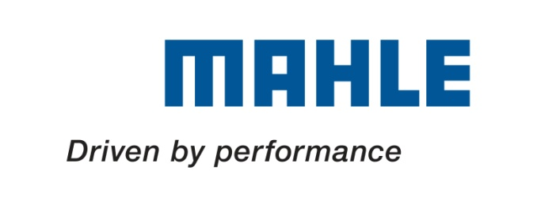
MAHLE is a technology leader in the areas of engine systems, filtration, electrics / mechatronics, and thermal management. In 2014, some 66,000 employees at approximately 150 production locations and ten major research and development centers are expected to generate sales of around ten billion Euros.

Supply Chain Internship (Logistics Planning)
Limited Duration Contract (12 Months) (Ref: MBZA-SC1)

Mahle Behr South Africa-Durban Plant based in New Germany, has an opportunity to fill in the above developmental position. This position will report to the Logistics Manager.

JOB REQUIREMENTS:
- Creation and maintenance of critical planning documentation such as:
  - Monthly/daily production plans
  - Production schedules
  - Plan vs actual comparisons
- Coordination of essential planning reviews across multiple departments.
- Ensure clear and regular communication of the Production plans to all appropriate business units.
- Maintain production KPIs to measure planning outcomes.
- Support the Planning Department as required by carrying out projects/tasks to achieve departmental objectives.
- Persistence in achieving and maintaining high standards , a systematic and organised in approach.
- Excellent communication, leadership and team work skills. Comfortable and effective approaches at various levels in the organisation are considered important personal attributes.

QUALIFICATIONS/EXPERIENCE:
- MS Excel intermediate level.
- No experience in the Planning function is required, but some experience in an administrative environment is an advantage.
- The purpose of this position is for a young person to gain valuable work experience, it is not a formal job
- Ideal for a Student who is completing part-time Masters or Doctoral studies. Time-off to attend to research will be granted
- Minimum qualification: Diploma / Degree or Post Graduate qualification in Economics, Supply Chain or related studies.

Interested persons should address their applications & supporting documentation to the HR Department via email: zadb_recruit@za.mahle.com

Closing Date: 21 September 2017
An Internship is not a fully responsible job hence a stipend is paid per month.
Preference will be given to previously disadvantaged individuals in accordance with the companies Employment Equity Plan.
South African citizens, ONLY.
Correspondence will be conducted with shortlisted applicants, only.

