Call to serve as Supervisor for the

3rd Southern African
Young Scientists Summer Programme
(SA-YSSP)

3 November 2014 – 31 January 2015

Closing date: 5 May 2014
Background

The National Research Foundation (NRF) as IIASA’s National Member Organisation (NMO), in collaboration with the Department of Science and Technology (DST) and the International Institute for Applied Systems Analysis (IIASA), is pleased to announce the third joint Call for Supervisors in continuing the Southern African Young Scientists Summer Programme (SA-YSSP). The Programme was launched by the Minister of Science and Technology in November 2011. The SA-YSSP is an annual three-month education, academic training, and research capacity-building programme jointly organised by the NRF, DST, and IIASA. The University of the Free State successfully hosted the first two rounds of the SA-YSSP during 2012-13 and 2013-14, and will again host the third SA-YSSP during 2014-15.

Objective of the SA-YSSP

The aim of the SA-YSSP is to provide an opportunity for excellent young doctoral students to advance their research under the direct supervision of senior scientists from IIASA and South African research institutions, and at the same time contribute to IIASA’s on-going scientific agenda and the DST’s strategic research agenda as documented in the ‘Grand Challenges’.

The programme offers scientific seminars covering themes in both the social and natural sciences, often with policy dimensions, to broaden the participants’ perspectives and strengthen their analytical and modelling skills. Keynote lectures are delivered by national and international leaders in their respective research fields, partly drawn from IIASA’s widespread network of alumni and collaborators, as well as from the NRF’s extensive international networks of excellence. The programme will be enhanced with specific field trips and cultural excursions, and may involve networking with national research programmes.

To ensure a rich international mix of participants and allow for exchanges and collaboration on projects that address global and regional challenges, the principal intake for the SA-YSSP from South Africa and the Southern African Development Community (SADC) will be complemented with 25% of placements reserved for young scientists from other IIASA member countries – up to 30 SA-YSSP participants in total.

The SA-YSSP’s curriculum will provide these young and emerging researchers with the following benefits:
- Supervision by experienced IIASA and South African scientists on a research project that is relevant to the participant’s doctoral research programme, as well as contributing to collaborative research by the supervising senior scientists.
- Broadening their research into interdisciplinary and trans-boundary research relevant to national, regional, and global needs.
- Opportunities for research publications in internationally accredited/ recognised scientific journals in collaboration with IIASA and senior South African scientists.
- Exposure to international research through interactions with national and international experts taking part in the programme’s supervision and seminar series.
- Exposure to local, national, and regional research programmes.
- Opportunities to build long-lasting collaborative contacts with the senior supervisors and with other programme participants.

Collaboration with IIASA and DST

IIASA is an independent international non-governmental research organisation, headquartered in Laxenburg, Austria, that provides science-based insights into complex global, regional, and national problems. IIASA conducts policy-oriented scientific research in three global problem areas:
- Energy and climate change
- Food and water
- Poverty and equity

Its three cross-cutting research areas are:
- Drivers of global transformations
- Advanced systems analysis
- Policy and governance

The following are IIASA’s current Research Programmes:
- Advanced Systems Analysis
- Ecosystems Services and Management
- Energy
- Evolution and Ecology
- Mitigation of Air Pollution and Greenhouse Gases
- Risk, Policy and Vulnerability
- Transitions to New Technologies
- World Population

South Africa’s engagements with IIASA and specifically with regard to the SA-YSSP relate primarily to the DST’s ‘Ten Year Innovation Plan,’ which has identified five ‘Grand Challenges’ of which the latter three are particularly relevant for the SA-YSSP, serving as enhancements and being complementary to IIASA’s research areas:
- Farmer to Pharma
- Space Science
- The Global Change
- Energy
- Human and Social Dynamics

Two primary cross-cutters between IIASA’s and DST’s agendas with regard to the SA-YSSP are human capital development with special focus on young and emerging researchers, and policy impact.

General call modalities

This third Call for Supervisors is aimed at accomplished South African researchers working in areas compatible with IIASA’s and DST’s strategic research areas to serve as supervisors for the 3rd SA-YSSP scheduled for 3 November 2014 to 31 January 2015. This call is directed at all working researchers residing in South Africa and affiliated with a recognised publicly funded higher education or research institution such as a university, university of technology, national facility, or science council. Responses must indicate at least one IIASA research scientist with whom prior contact has been established.

The general modalities of this call are as follows:
- The applicant must be in possession of a PhD.
- The applicant must reside in South Africa and work at a recognised publicly funded university or research institution. Commercial institutions and private education institutions are NOT eligible to apply under this programme.
- The applicant has identified a research area, and ideally a potential research partner, at IIASA that is compatible with and/or complementary to his or her own research agenda and expertise.
- It is recommended that each potential team of senior supervisors indicate at least one postdoctoral fellow who could serve as assistant supervisor and stay in Bloemfontein for at least one month during the SA-YSSP’s core period.
- Applications will be received by the NRF and screened by the SA-YSSP Steering Committee consisting of representatives of NRF, DST, UFS, and IIASA.
- South African supervisors selected for the SA-YSSP will be required to sign a mandatory clause to ensure that adequate supervision is given to SA-YSSP doctoral students. NRF will enter into a contractual agreement with the selected, successful SA-YSSP supervisors.

Structure of the SA-YSSP
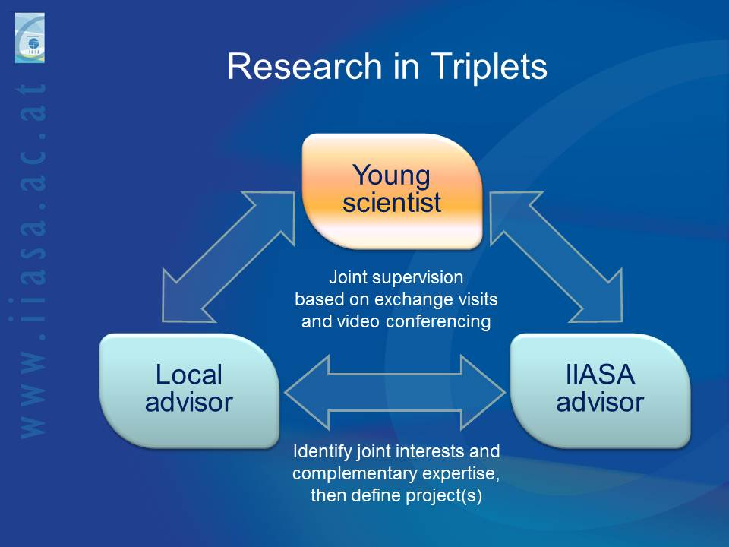

Figure 1. Research in Triplets

The SA-YSSP will be based on the “Research in Triplets” framework (Figure 1), through which one South African researcher and one IIASA researcher will jointly supervise one or more SA-YSSP young scientists (in selected cases, there may be more than one South African or IIASA supervisor):
- The two senior supervisors will, prior to the start of the SA-YSSP, define collaborative research contributing to IIASA’s on-going scientific agenda and/ or to one of the DST’s ‘Grand Challenges’.
- Each young scientist’s SA-YSSP project will then be designed to contribute to the collaborative research agreed upon by the two supervisors.
- It is foreseen that 1-4 young scientists will be affiliated with each pair of supervisors.
- The young scientists will prepare – jointly or individually, as advised by their supervisors – one or more corresponding collaborative research publications to document research accomplishments during and after the SA-YSSP participation.

The NRF will provide opportunities for all successful South African SA-YSSP supervisors to travel to IIASA, prior to the commencement of the programme, to advance the collaborative research and to familiarise themselves with IIASA’s prestigious Young Scientists Summer Programme (YSSP), which has inspired the development of the SA-YSSP. Each of these visits is envisaged for a period of 1 week and will be timed according to the collaborating supervisors’ schedules and preferences.

Young scientists will be in residence at the SA-YSSP hosting institution, the University of the Free State, Bloemfontein, South Africa for three months from 3 November 2014 to 31 January 2015. South African supervisors will be expected to be in residence for 3-4 weeks during that period, and IIASA supervisors for 1-2 weeks during that period. When not in residence, the supervisors will commit to being in regular contact with their SA-YSSP mentees and collaborators via email, phone, and regular video conferencing. During the festive period (23 December 2014 – 1 January 2015), all necessary support will continue to be provided to the participating young scientists.

It is anticipated that the “Research in Triplets” format will realise a mutually beneficial situation contributing to the following desirable outcomes:
- Strengthening and extending collaborative links between the South African research community and IIASA
- Allowing all collaborating scientists, and especially the participating young scientists, to learn from the experience of their colleagues
- Fostering innovative research in South Africa
- Constructive contributions to IIASA’s research agenda

Interested scientists are encouraged to demonstrate how they will meet these expectations by describing their research and supervision expertise. They should address in particular the relevance of their research interests to IIASA’s on-going scientific agenda and DST’s Grand Challenges. Applicants who have taken active steps towards establishing plans for joint supervision with an IIASA researcher will be favoured in the selection process.

The NRF will cover the financial costs to be incurred by the SA-YSSP supervisors within stipulated guidelines, including travel, accommodation, and meals. South African supervisors will, in addition, receive a taxable honorarium of ZAR 60 000 for their comprehensive supervisory efforts, which are to include preparatory discussions, regular and intensive supervision throughout the SA-YSSP’s three-month period, 3-4 weeks of on-site supervision, and subsequent supervisory work needed to ensure the intended research publication. This honorarium must be processed by the HR department of the supervisor’s institution according to South African tax guidelines.

Supervisors are encouraged to nominate suitably skilled postdoctoral fellows to serve as assistant SA-YSSP supervisors. If these are currently affiliated with a South African university or science council, this will be helpful.

Expectations to be met by South African SA-YSSP supervisors:
- Define collaborative research with an IIASA researcher, to serve as the basis for the joint supervision of one or more SA-YSSP young scientist(s).
- Commit to a visit to IIASA, especially for new collaborators, to strengthen the envisaged collaborative research agenda.
- Preparatory activities in cooperation with the IIASA co-supervisor to 1) describe collaborative research to be included in the SA-YSSP Call for Participants, 2) evaluate and rank the corresponding applicants, 3) conduct preliminary correspondence and planning with the corresponding accepted SA-YSSP participants and 4) select a research associated postdoctoral fellow.
- Commit to the joint supervision of 1-4 doctoral students selected as SA-YSSP participants during and after the three-month SA-YSSP period.
- Commit to spend 3-4 weeks at the University of the Free State during the SA-YSSP period to ensure strong supervisory oversight. During this stay, part-time involvement in the SA-YSSP will usually suffice, leaving enough room for selected supervisors to honour their other on-going commitments.
- Commit to regular contacts by email, phone, and video conferencing with the IIASA co-supervisor and the corresponding SA-YSSP participants throughout the SA-YSSP period to provide intensive supervision and ensure appropriate progress of the collaborative research.
- Commit to exploring the possibility of, and making efforts towards, the joint publication of research results obtained through the collaborative research during and after the SA-YSSP period in internationally recognised scientific journals.
- Commit to the joint evaluation of the SA-YSSP.
Application materials

Scientists wishing to serve as supervisors for the SA-YSSP should submit an application to the NRF. The application should include:
- A description of (1a) research interests and how these relate to (1b) IIASA’s on-going research agenda as well as to (1c) DST’s ‘Grand Challenges’.
- CV (including a full record of publications, postgraduate student supervision, and grants awarded).
- Optional, but strongly recommended: A letter from an IIASA research scientist confirming interest in research collaboration as part of the SA-YSSP.

Application procedure

Application forms for South African applicants may be downloaded electronically from the NRF website (http://www.nrf.ac.za/). A compulsory soft copy and the signature page (scanned) of the application must be submitted to:

Mr Teuns Phahlamohlaka (Professional Officer)
Teuns.phahlam@nrf.ac.za

No hard copies of the application can be accepted and will be automatically disqualified by the NRF. Only applications endorsed by the research office or its equivalent at higher education or research institutions will be accepted.

Useful links

http://www.ufs.ac.za/sa-yssp
http://www.dst.gov.za/
http://www.nrf.ac.za/
http://iiasa.ac.at
http://www.iiasa.ac.at/web/home/research/researchPrograms/Research-Programs.en.html
http://www.iiasa.ac.at/web/home/education/sayssp/About-the-Program.en.html

The closing date for complete submissions is Monday, 5 May 2014

For further information, please contact:
Mr Teuns Phahlamohlaka
Professional Officer: Overseas Cooperation
National Research Foundation
Tel: +27 (0)12 481 4385
E-mail: teuns.phahlam@nrf.ac.za

