Westville Aerobics Club
Due To Load Shedding, Our Aerobics Classes Have Now Changed Time Slots….Please Come Join Us From This Monday (27 July) As We Get In Shape, Ready For SUMMER!!

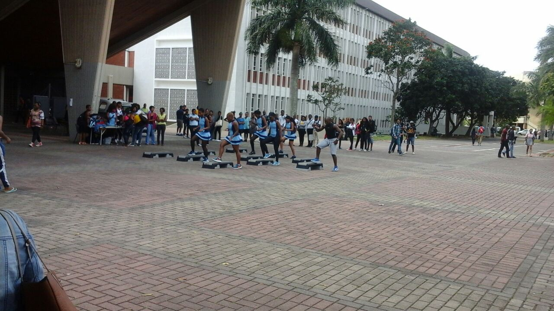

MONDAY & TUESDAY - 18h:00pm
WEDNESDAY & THURSDAY – 17h:00pm
Contact: Slie 0795348084…..Siwe 0743079265
Mpumie 0782217076…..Anele 0783525959
Nrateng 0839966587

