**The UKZN Centre for Civil Society is inviting you to Centre for Civil Society - Special Webinar Series “2024 Election Voter Education and Registration”.**

**In 2024, South Africa is gearing up for its next general elections. These elections will play a pivotal role in selecting a fresh National Assembly and shaping the provincial legislatures in each region. Notably, these upcoming elections mark the seventh occasion of such democratic processes carried out since the end of apartheid in 1994, with universal adult suffrage as the cornerstone. To empower and engage citizens, this enlightening webinar will focus on demystifying voter education and simplifying the registration process. The overarching aim is to inspire widespread participation and active involvement in the upcoming 2024 elections.**

**Facilitator: Ben Madokwe**

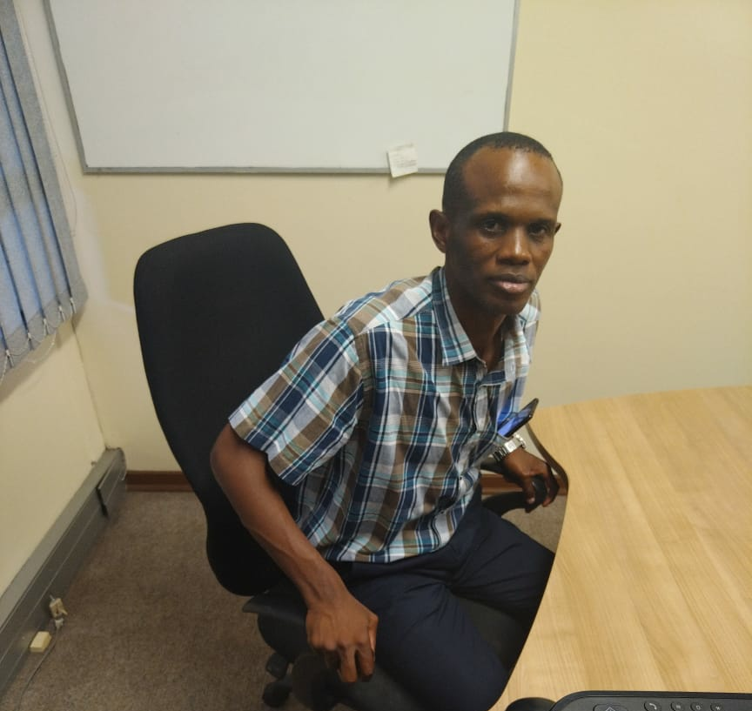

Ben Madokwe is an activist and works at Right to know (R2K). He is mainly overseeing one of the important pillars at R2K on national level and provincial level which covers different programs including Participatory democracy, Countering Patriarchy, Communication rights and Countering repression.

**speakers: Professor Paulus Zulu and various Youth Leaders**

**Date & Time: 15 September 2023, 13:00-15:00**

**Zoom Link:** <https://ukzn.zoom.us/j/91420737902?pwd=TXpOTzhwR3cxY2hTRERyODVaZmJFUT09>

**Topic:** **Voter Education and Voter Registration**

**Speaker Bios:**

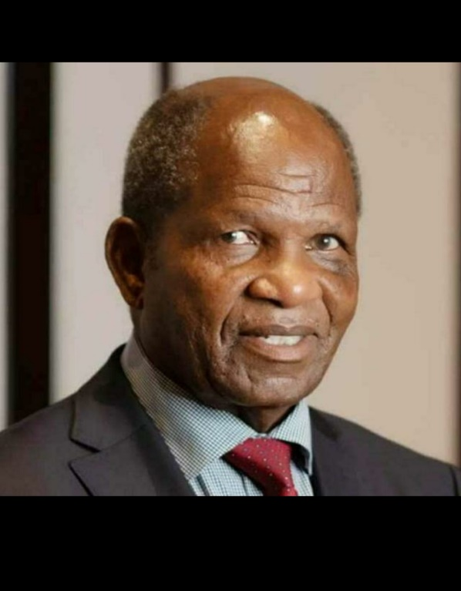

Professor Paulos Muzomuhle Zulu has a passion for education, youth development and the promotion of black academia. In 1986 he started a post-graduate research internship as a training ground for African academics. He organised a Saturday School Programme and the University of Natal for Grades 10 to 12. Over a thousand learners went through the school each year, with the majority improving their matric grades against tough odds. As Pro-Vice Chancellor of Students, he instilled a culture of accountability, discipline and moral probity in the student leadership and governance. His Unit has developed a curriculum in leadership and governance for Amakhosi and currently twenty-two Amakhosi are studying for this certificate at UKZN. Born on 28 July 1941 in Ixopo. A social scientist by training, Professor Paulus Zulu holds qualifications in diagnostic radiography and marketing management. He obtained his PhD from the then University of Natal, publishing extensively in the fields of politics and sociology, both nationally and internationally. Since 1984, Zulu has written numerous chapters in books, including The Hefer Commission: An International Comparative Perspective issued in 2004 and Understanding the South African Political Culture published in 2012. In 2013, Zulu’s debut book, A Nation in Crisis: A Search for Morality, was released. He is also a Director: Maurice Webb Race Research unit.

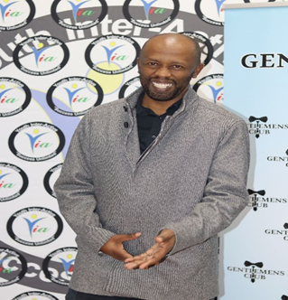

Mr Sbongiseni Nkomo is a Regional Assistant Manager (RAM) for IEC where he is responsible for Local Project Administration and this includes developing, communicating and implementing effective performance work plans to achieve set performance targets and goals. He also works on Local Electoral Operations where he coordinates activities to conduct National, Provincial and Local government elections.

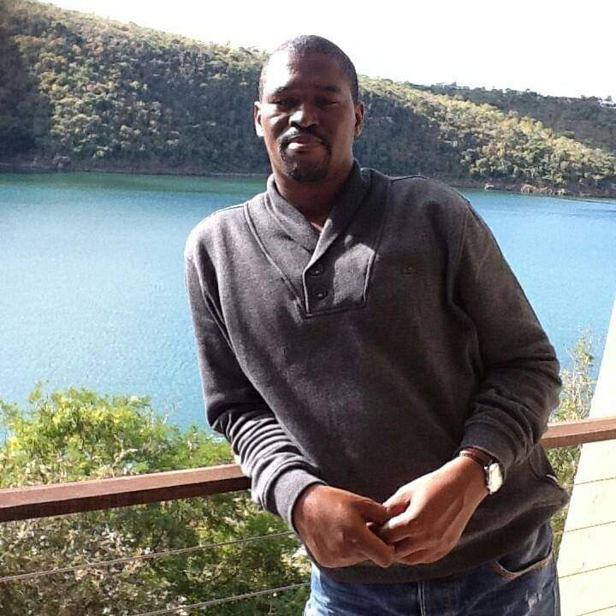

Malusi Msomi is a Regional Outreach Officer at the IEC where he is drives provincial civic and democracy education, Identify and manage strategic stakeholder issues and audiences. He also manages responsibilities of all stakeholders, political parties, candidates and the electorate. As we as coordinate and facilitate mass civic and voter education initiatives and he oversees communications to the media including content initiatives cultivate and manage relationships with media representatives.

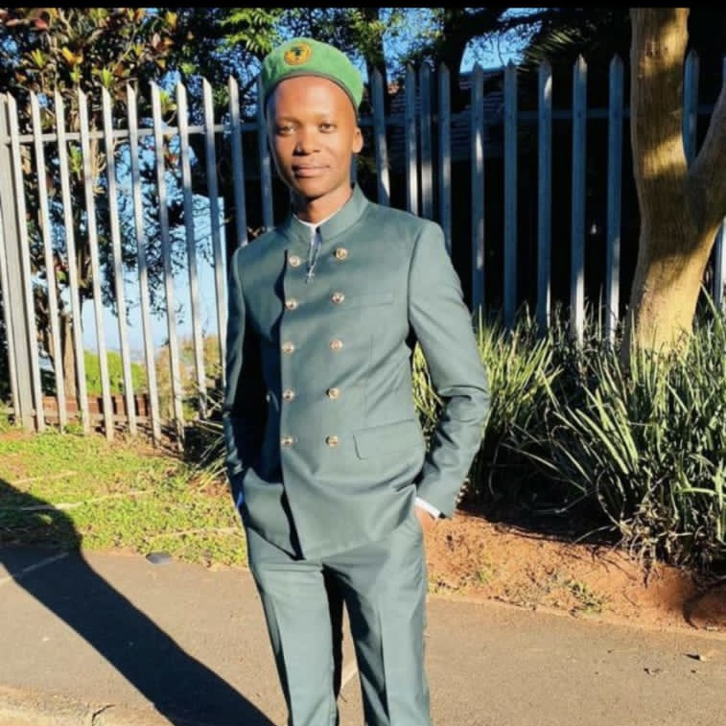

Simphiwe Xulu is a Youth Leader for SASCO

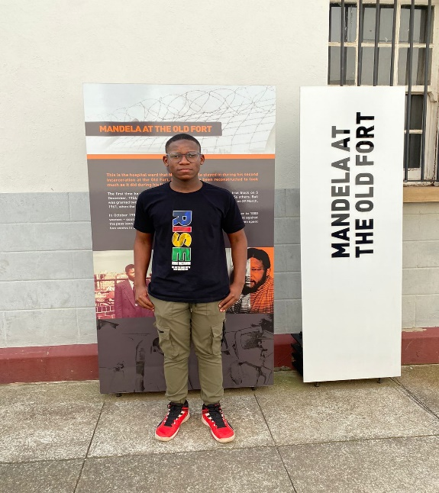

Lawrence Manaka (Equal Education) Lawrence Manaka is a Student Chapters and Youth Coordinator at Rise Mzansi.

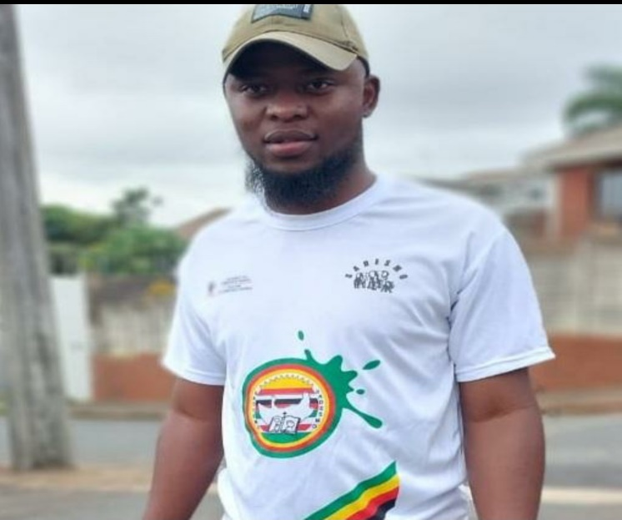

Mduduzi Sithole from Ladysmith is a member of IFP and currently acting as SADESMO Chairperson.

Andile Shange is a Justice activist and a student activist under the Economic Freedom Fighters Students Command