Connecting to UKZN network for APPLE MAC Users

1. Access the VPN web portal at https://vpn.ukzn.ac.za
2. Login with your UKZN credentials
3. Download and install FortiClientInstaller-Mac- Enterprise

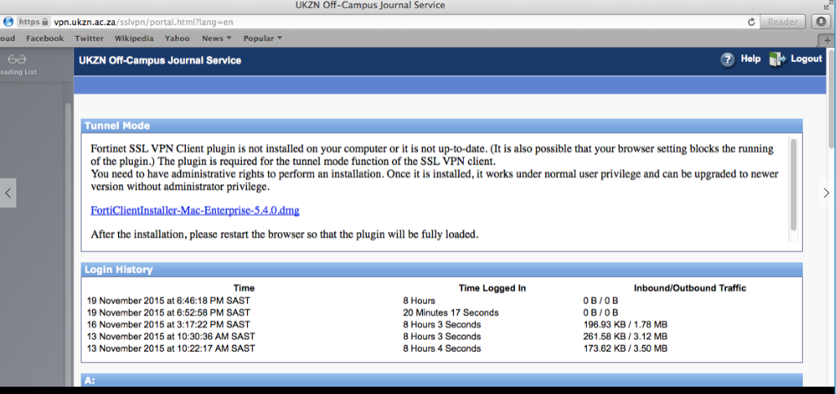

4. If you get the below displayed warning, click open

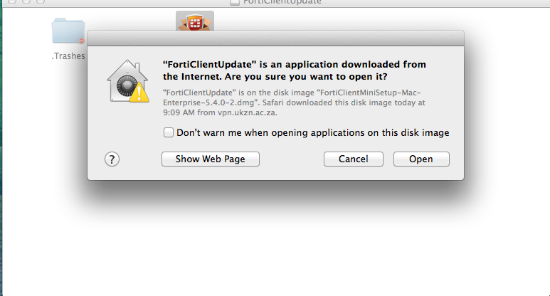

5. Click Continue until you can see install and proceed to install.

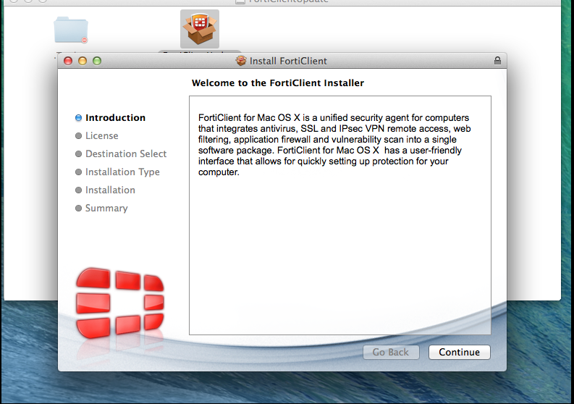

6. After the installation has completed, Click Finder, Click Application and open Forticlient

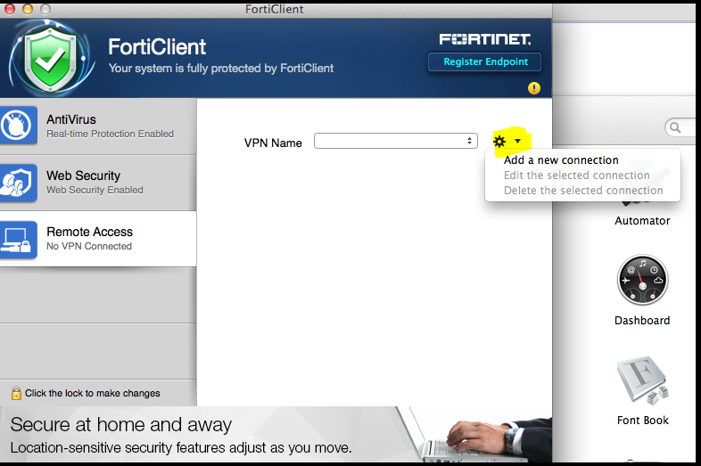

- Configure details as follows:

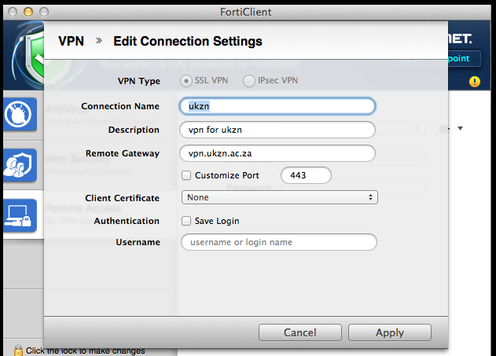

- Click apply and login using your UKZN credentials, Click Connect

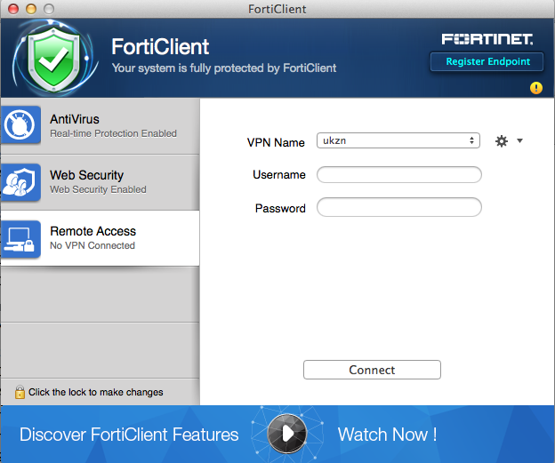

- You will now be connected to the UKZN network via VPN client, and once connected you can go to http://library.ukzn.ac.za (there is no need to click off campus access). You will be able to access journals as long as you stay connected on VPN. Once done please go Forticlient screen and disconnect.

