YOUTH IN BLOOM
Building Main Character Energy
“The spotlight’s waiting—walk in.”

Hey Students!
We’re thrilled to introduce The Halcyon Theatre’s Youth in Bloom project—a vibrant, creative space on campus designed to help you grow, flourish, and bloom into the best version of yourself! 🌸

Just like a flower pushing through the soil to reach the sun, this project is all about your journey—embracing your potential, finding your voice, and connecting with others in a space that celebrates growth. Whether you’re navigating the twists and turns of student life or simply looking for a place to express yourself, reflect, and thrive, Youth in Bloom is here for you.

Why Join?
- 🌻 Bloom Boldly: This isn’t just about "managing stress"—it’s about unlocking your best self through creativity, movement, and storytelling.
- 🎭 A Theatre of Transformation: Inspired by The Halcyon Theatre’s mission to reimagine health education, we’re creating a space where your experiences shape what wellness truly means.
- 🤝 Grow Together: Connect with peers in group sessions or explore your journey one-on-one—because growth is better when it’s shared.

When & Where?
📅 Every Wednesday
⏰ 9:00 AM – 12:00 PM
📍 Multipurpose Room (OT Department)
🔗 Book a session: http://calendly.com/halcyontheatre0
📩 Email us: halcyontheatre0@gmail.com

Ready to bloom? 🌿
Join us, drop in, or just spread the word—every petal of your journey counts.
– The Halcyon Theatre Team

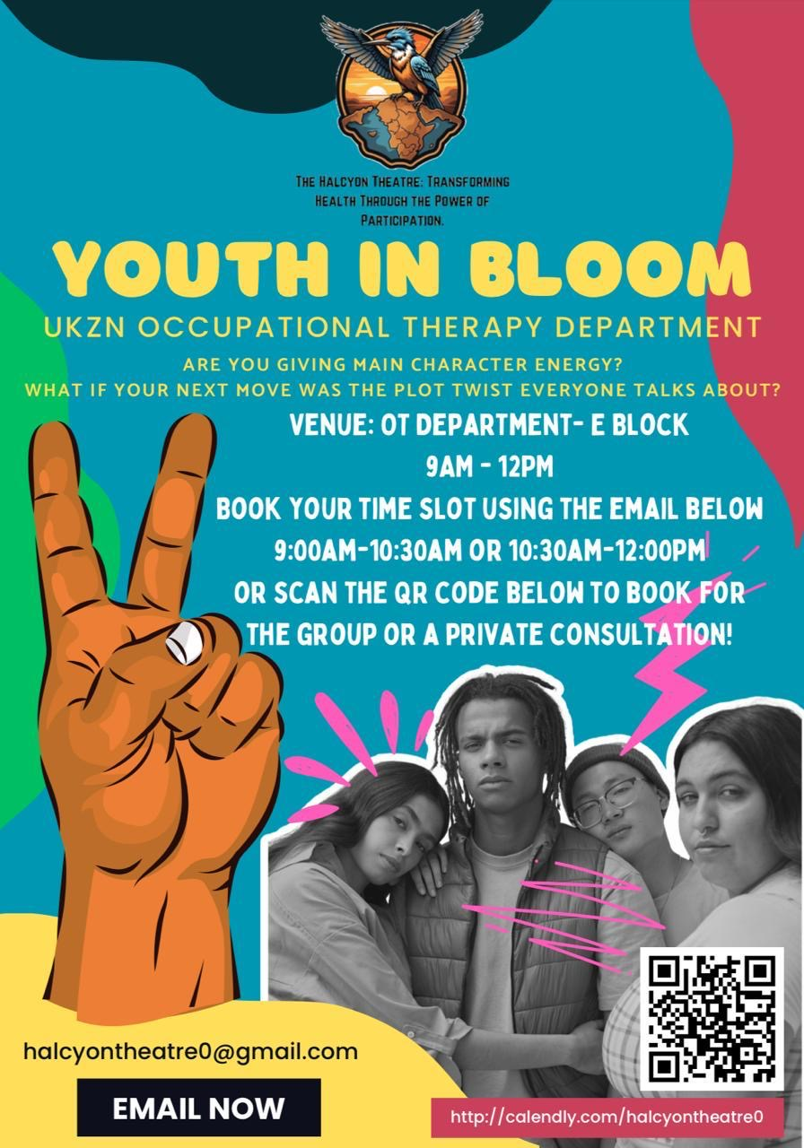 | 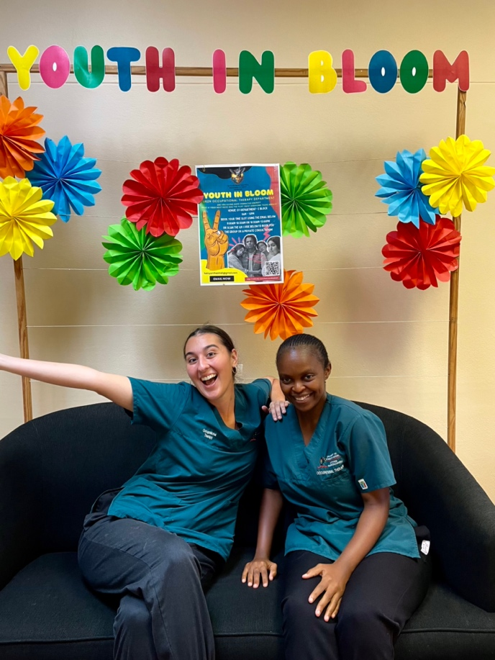
Picture 1: Youth In Bloom Advert (look for these adverts around The University of KwaZulu-Natal Westville Campus) | Picture 2: Occupational Therapy 4th year Student therapists- Savannah Prange (left) and Asivenathi Plaatjie (right)

