CLMS Student Support Services (SSS): First Semester 2025 group sessions
(Skills for success ; Career Development; Support Groups)

Group session | Date and time | Information/Zoom link and contact person
Resilience: Surviving and Thriving in University! | Monday, 14 April  @12:20-13:20 | The journey to getting your degree is not an easy task. It is filled with different challenges along the way. Some of these challenges tend to dim your hopes of getting a degree. They can cause a lot of frustration and feelings of helplessness. Join us for an empowering session designed to help you build resilience and excel in your university journey. We will provide practical strategies to manage stress, stay organised and maintain a positive mindset. You will learn how to navigate through these different challenges. With the right approach and mindset, you will not only survive but thrive in university!  So, do not miss this opportunity to enhance your resilience and make the most of your university experience.  Join Zoom Meeting: https://ukzn.zoom.us/j/93189652300?pwd=Gqj3Ny8JXgcAY1SyNkeY8MRoxhyEaB.1  For more information, please contact Ms Nonhlonipho Biyela at BiyelaN@ukzn.ac.za
Top Tips for Time Management | Wednesday 16 April, 10h00 – 11h00 | Top Tips for Time Management for CLMS Students  • Would you like to feel more in control of your life?  • Do you lack the correct skills to complete your work?  • Are you failing to bring out the best in yourself?  • Do you start your semester strong, then somehow fizzle out?  • Would you like to feel that there is time in your life for everything?  • Would you like to feel more excited about your life and academic work?  • Do you keep putting things off?  • Do your stress levels get in the way of your studying?  Zoom link: https://ukzn.zoom.us/j/95595333264  Contact Dr Margot Sennett Freedman at sennett@ukzn.ac.za for any further information.
Note-taking  and  Study Skills | 17 April 2025  @12:20 | Taking notes is more than just writing things down. It's about organising information in a way that helps you understand and remember it. This session introduces several note-taking methods, from the Cornell system to mind maps, and teaches you how to actively engage with material during and after lectures. Great for boosting your academic performance across all subjects.  Join Zoom Meeting  https://ukzn.zoom.us/j/98915675959?pwd=Wzjv5an7Z8bicSzVn4GXqrofFMjaLJ.1  Meeting ID: 989 1567 5959; Passcode: 809604  For inquiries, contact Vuyiswa Khanyile at:Khanyilev@ukzn.ac.za and Silindile Zulu at: zuluS2@ukzn.ac.za
CLMS PHD Support Group | Fortnightly online group  Every 2nd Monday from 14 April 10H00 – 11H00 (SAST) | Pursuing a PhD can be as isolating as it is inspiring. This online, fortnightly, hour-long support group is a safe, inclusive space for registered CLMS PhD students to connect, share challenges, celebrate wins, and navigate the ups and downs of academic life. Whether you're grappling with writer's block, impostor syndrome, supervisor stress, or need a reminder that you're not alone, this group offers community, encouragement, and practical tools for wellbeing.  Come as you are—because no one should have to do a PhD alone.  Contact Dr Margot Sennett Freedman at sennett@ukzn.ac.za for any further information.  Zoom link for every session: https://ukzn.zoom.us/j/93056571028
Anxiety and Depression Support Group | 22 April 2025  06 May 2025  20 May 2025  27 May 2025  @12:20 | University life can be exciting, but it also comes with pressures that may feel overwhelming. Are feelings of low mood affecting your studies and wellbeing? You're not alone!  Join Vuyiswa Khanyile and Silindile Zulu for an engaging 1-hour session where we'll unpack the realities of depression and anxiety, explore how they affect university students, and equip you with practical coping strategies to navigate academic life with resilience.  Join Zoom Meeting: https://ukzn.zoom.us/j/94168026614?pwd=hHXhJbil9e2rbHlMr4yZSaTntywZBk.1  Meeting ID: 941 6802 6614; Passcode: 288588  For inquiries, contact Vuyiswa and Silindile at:Khanyilev@ukzn.ac.za or ZuluS2@ukzn.ac.za
The Sisters Corner | Every second Friday  25 April  9 May  23 May  @12:20-13:20 | The Sister's Corner is a platform created by SSS for female students to have real and honest conversations about matters that impact women in the present age. This is a wonderful opportunity to network with like-minded people, to share personal experiences and feelings, coping strategies, or first-hand information about the topic being discussed in a safe and professional environment. Join us as we provide bi-weekly (every 2 weeks) sessions covering timely and emerging issues impacting women (female students).  Who is the session aimed at: All female students who want to engage in conversations about women's matters.  Join Zoom Meeting: https://ukzn.zoom.us/j/96768627687?pwd=K8bDpgxYpLWqTuPkbfbmhZJbbuRFjU.1  For further information contact Nonhlonipho Biyela Biyelan@ukzn.ac.za ; Snethemba Gwambe GwambeS@ukzn.ac.za; Vuyiswa Khanyile at:Khanyilev@ukzn.ac.za and Silindile Zulu at: zuluS2@ukzn.ac.za
Stress Management Workshop | 23 April 2025 @ 12:20  https://ukzn.zoom.us/j/99129388369?pwd=19NqaXfaCKovkNUXgIukAorQQJKEWx.1  14 May 2025 @ 12:20  https://ukzn.zoom.us/j/93254647786?pwd=N2RsGXGbRkU3fTrDhaei7pMx03VLNT.1 | Feeling overwhelmed by tests, assignments, and everything else that comes with university life? Join us for "Stress Management"—a workshop focused on helping you manage stress better and take care of your mental well-being. We'll cover practical coping techniques, how to recognise burnout, and ways to build resilience. You'll also learn how to balance academics, relationships, and self-care without feeling stretched too thin.  For more information please contact Snethemba Gwambe (GwambeS1@ukzn.ac.za)  23 April 2025 @ 12:20  https://ukzn.zoom.us/j/99129388369?pwd=19NqaXfaCKovkNUXgIukAorQQJKEWx.1  14 May 2025 @ 12:20  https://ukzn.zoom.us/j/93254647786?pwd=N2RsGXGbRkU3fTrDhaei7pMx03VLNT.1
Email and Digital Communication etiquette | 24 April 2025  @12:20 | In a world where emails, messages, and online profiles are part of everyday life, knowing how to communicate professionally is essential. This session will cover how to structure a clear and polite email, understand digital tone, avoid common mistakes, and make a strong impression online. We'll also explore how to present yourself professionally on LinkedIn. Whether you're contacting a lecturer, applying for a job, or collaborating online, effective communication sets you apart.  Join Zoom Meeting: https://ukzn.zoom.us/j/98820585228?pwd=uwtQRIw4PygkS0bilNLgLq9j4SNhIU.1  Meeting ID: 988 2058 5228; Passcode: 423044  For inquiries contact Vuyiswa Khanyile at:Khanyilev@ukzn.ac.za, Silindile Zulu at: zuluS2@ukzn.ac.za or lufundoY@ukzn.ac.za
Managing Test Anxiety | 5 May 2025  @12:20 | That sinking feeling before a test? You're not alone. This session helps you understand test anxiety, why it happens, and how it affects performance. You'll walk away with calming techniques, study adjustments, and mindset shifts that help reduce stress and boost confidence so you can face your next exam with greater ease and focus  Join Zoom Meeting: https://ukzn.zoom.us/j/96404657567?pwd=b2aeDLfXqRfrJzRJTSkHSvNhhLegmd.1  Meeting ID: 964 0465 7567; Passcode: 618361  For inquiries, contact Vuyiswa Khanyile at:Khanyilev@ukzn.ac.za and Silindile Zulu at: zuluS2@ukzn.ac.za
Ace Your Exams!  Turn Stress into Success! | Wednesday, 7 May 12pm – 1pm  https://ukzn.zoom.us/j/97535252597  Thursday, 15 May 11am – 12pm  https://ukzn.zoom.us/j/92490427412 | 🎓 EXAM SUCCESS STARTS HERE! 🎓  Join our Ultimate Study Skills & Exam Prep Workshop!  Feeling overwhelmed by exams? Not sure where to start with your study schedule? We've got you covered! This power-packed, practical workshop is designed for students like you — whether you're struggling with motivation, time management, exam stress, or simply need a smarter way to study.  🔥 In this dynamic session, you'll learn how to:  Master time management with flexible, realistic study plans  Study smarter using mind maps, mnemonics & past papers.  Organise your materials and prep effectively with a monthly and weekly planner.  Avoid last-minute cramming and exam-day disasters.  Form supportive, productive study groups.  Handle stress with proven breathing & relaxation techniques.  Approach exams with confidence — from the night before to the final answer check  💡 PLUS: Get real answers to real student FAQs, like:  "Why can't I stick to my study schedule?"  "How do I study four subjects in two weeks?"  "How can I stay focused without getting bored?"  🎯 Whether you're a first-year just getting started or a seasoned student ready to level up — this workshop will help you turn stress into success.  👉 Don't miss it — your exams will thank you later!  Contact Dr Margot Sennett Freedman at sennett@ukzn.ac.za for any further information.
Dealing with End of Semester Fatigue | 12 May, Monday  @12:20 | As the semester winds down, the pressure of final exams, assignments, and projects can leave you feeling drained. This workshop is designed to help you navigate the challenges of end-of-semester fatigue and boost your mental and physical well-being. Through practical strategies, you'll learn how to manage stress, stay focused, and maintain your energy levels during this busy time. Join us for a rejuvenating session and learn how to overcome burnout while maintaining your productivity and motivation!  For more information, please contact Ms Nonhlonipho Biyela at Biyelan@ukzn.ac.za  Join Zoom Meeting: https://ukzn.zoom.us/j/91327756767?pwd=ztKq7xK0EJR9MMomXRtRvjTzeP8Ikb.1
Work Readiness | 9 April | 
 | 16April | 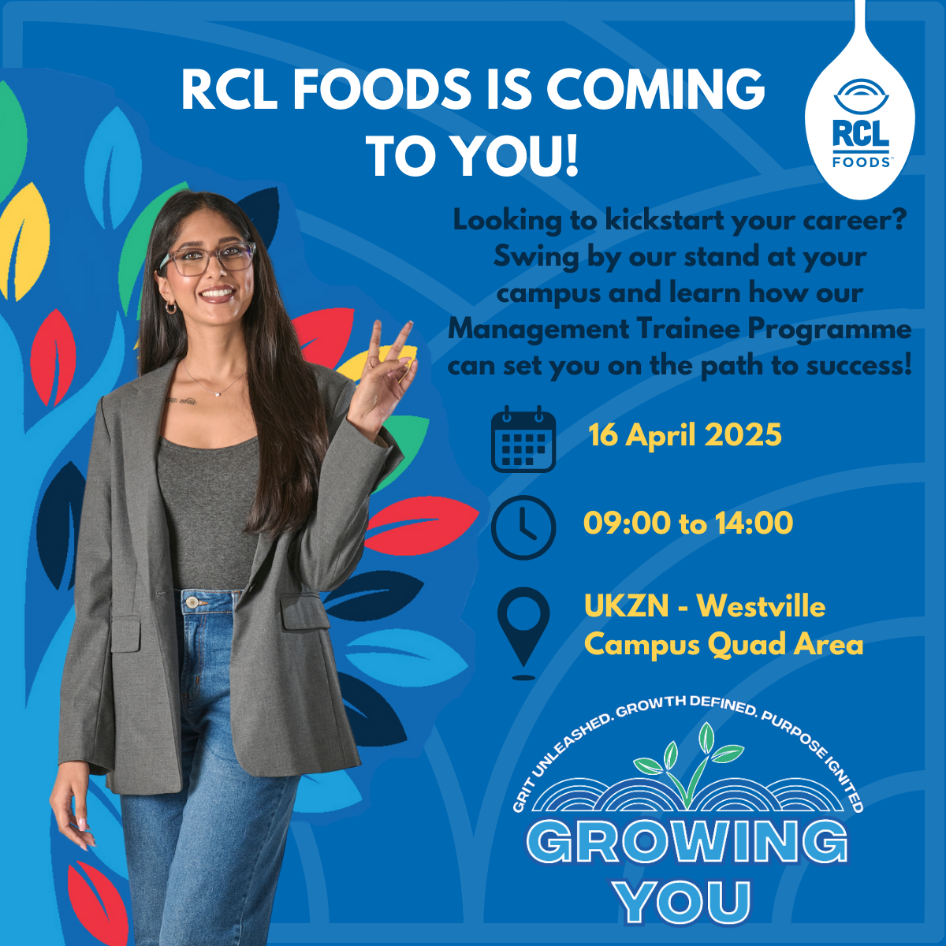
 | 17 April | 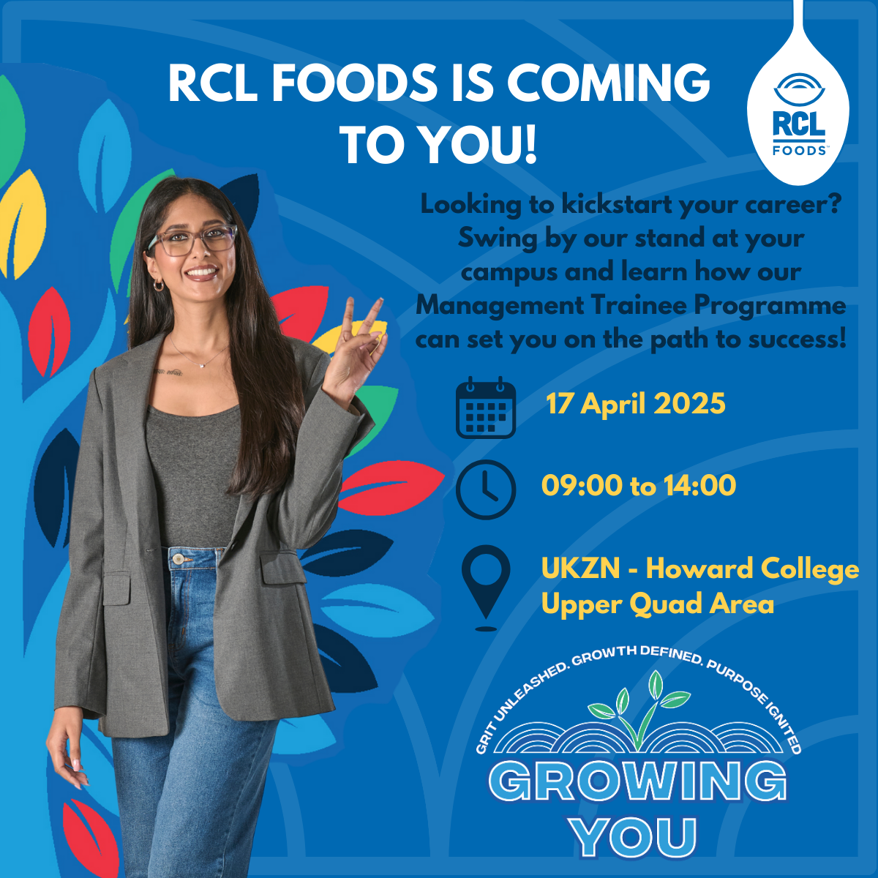
CLMS STUDENT SUPPORT SERVICES (SSS) -INFORMATION AND LINKS TO THE SERVICE
THE CLMS SSS SHARE POINT:
The CLMS SSS Share point links you to SSS. You will receive updates on all the SSS services and notices, including job/internship adverts, workshops, etc. and have access to the online resources.
CLMS SSS link: https://stuukznac.sharepoint.com/sites/clmsstudentsupport
WHERE TO FIND US
Pietermartizburg campus: College Administration Office, 1 Golf Road
Westville Campus: Level 3, L Block
Howard College campus: Level 5, Dennis Shepstone Building, Rooms C504 and C507
E-mail | clmssss@ukzn.ac.za
Website | https://clmsstudentsupport.ukzn.ac.za/
ONLINE BOOKING: https://clmsstudentsupport.ukzn.ac.za/book-online
TOLL FREE NUMBER: 080 080 0017
FRONT DESK ADMINISTRATOR: 031260 7337

Students can register on the SSS Career Development database using the following link:
https://stuukznac.sharepoint.com/sites/clmsstudentsupport
SSS Website: https://clmsstudentsupport.ukzn.ac.za/

