**Centre for Civil Society - Seminar on US Funding and the State of Civil Society in South Africa**

The U.S. President’s Emergency Plan for AIDS Relief (PEPFAR) has been instrumental in curbing the HIV epidemic, preventing millions of new infections through critical interventions such as voluntary medical male circumcision, prevention of mother-to-child transmission (PMTCT), and widespread access to antiretroviral therapy (ART). Beyond direct HIV services, PEPFAR’s investments have strengthened healthcare infrastructure, trained healthcare workers, and enhanced laboratory and supply chain systems, building resilient health systems capable of addressing not only HIV but also broader health challenges. Additionally, PEPFAR has empowered community-based organizations, fostering local ownership of the HIV response and improving service access for key populations. However, the recent freeze in PEPFAR funding threatens to disrupt essential HIV testing, treatment, and prevention services, particularly in resource-limited settings and among marginalized groups. This seminar examines the potential consequences of funding interruptions, explores strategies for mitigating harm, and discusses the long-term implications for global HIV control and health system stability.

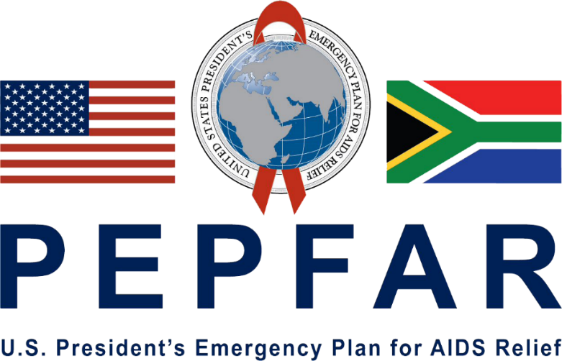

**The UKZN Centre for Civil Society is inviting you to a Zoom Session of the CCS Webinar Series**

**Please note changing times to accommodate speakers from international time zones:**

**Facilitators: Mzamowenkosi Zondi & Ben Madokwe**

**Seminar:** Defunding health justice: The consequences of US foreign aid withdrawal for South African communities

**Speakers:** Nkosikhona Mpungose & Siyabonga Nzimande

**Date & Time:** Tuesday, 22 July 2025, 15:00-16:00 (SA Time)

Zoom Link: <https://ukzn.zoom.us/j/96653472629?pwd=epLRPJW31h9K0AfMAC7SttY9d6a8Ua.1>

**Speakers Bio:**

**Siyabonga Nzimande** is a dedicated public health expert, human rights advocate, and researcher with over 20 years of experience working within civil society, academic institutions, and advocacy platforms both locally and internationally. He holds a Master's degree in Psychology (Human Behaviour) and a Basic Science degree from Stellenbosch University. He is currently pursuing his PhD with Pencivenia University in the USA, focusing on Human Rights and Advocacy in Public Health. His work has contributed significantly to TB and HIV research and programming, collaborating with global agencies such as the Stop TB Partnership and the TB Alliance (USA). Siyabonga has held leadership roles at district, provincial, and national levels, including serving within SANAC's TB Sub-Sector and contributing to national advocacy initiatives focused on health equity, children's rights, and civil society strengthening. Passionate about research and development, Siyabonga continues to champion evidence-based approaches in public health programming, with a special commitment to the advancement of human rights within healthcare delivery.

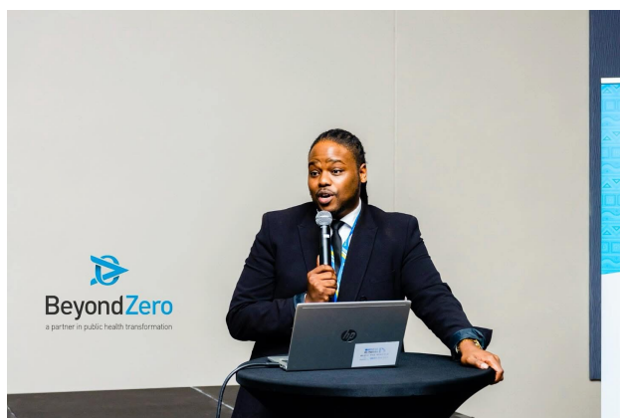

**Nkosikhona Mpungose**, is the Executive Director of Youth Inter-Active and serves as a chairperson for eThekwini Civil Society Forum, and a dedicated member of the INFORM Africa CAB. He considers himself as an activist for reform and best practice in the Public Health sector with over 10 years’ experience in Sexual Reproductive and Health Rights for Adolescents and young people. He has served in the capacity of the KZN Youth Sector for 10 years and has been involved with CAPRISA as a CAB member for 10 years as well. Currently, he is the Civil Society Youth Rep at Stats SA on SDG country report and the commissioner for National Planning Commission under youth programs. He also serves as a Deputy Chairperson for the Board of the South African Youth Climate Change Coalition.

