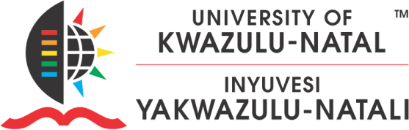 http://web.unitn.it/files/editor/internazionale/eu_flag-erasmus_vect_pos.jpg

# CALL FOR ERASMUS+ STAFF MOBILITY AT THE

**MEDICAL UNIVERSITY OF SOPHIA – BULGARIA**

Erasmus+ is the EU's programme to support education, training, youth and sport in Europe. The program offers mobility opportunities for both staff and students in higher education and training through collaborations and exchange programs. (For more opportunities, please check this page <https://erasmus-plus.ec.europa.eu/about-erasmus/what-is-erasmus>).

# ACADEMIC/TEACHING STAFF MOBILITY (STA)

(Teaching opportunity at higher education institutions (HEIs) abroad).

UKZN has an inter-institutional agreement with the Medical University of Sophia which has a teaching opportunity for UKZN Academic Staff from the Health Sciences.

The call for application is open to academic/teaching staff in the following fields **Pharmacy/** **Oncology / Endocrine / Public Health.**

The mobility will be for 7 days (2 travel days + 5 days for activities). The mobility will have to take place by **31 July 2025**.

## Mobility selection criteria:

* The applicant should demonstrate a good scientific background and expertise in the field of studies/work of the proposed mobility.
* Letter of support from the line manager, indicating the value of the mobility to UKZN.
* Signed staff mobility agreement.(attached )

## Grant for mobility candidate

The grant subsidy is 140 euros per day and 1500 euros for return travel costs.

## Overall expectations of the visiting academics.

* + Engage in teaching activities, delivering 2 lectures / 2 seminars at the host institution.
  + Foster international collaboration and exchange of knowledge with local faculty and students.
  + Contribute to the development of innovative teaching methods and interdisciplinary approaches.
  + Enhance the academic quality and diversity of the host institution by sharing expertise and best practices.
  + Act as cultural ambassadors, promoting mutual understanding and tolerance through academic interactions.
  + Participate in academic events or research projects to enrich the academic environment.
  + Contribute to the Internationalisation of the host institution by integrating global perspectives into the curriculum.
  + Foster long-term partnerships and collaborations between the host institution and their home university.

**Closing Date: 30 June 2025**

For any other enquiries interested candidates may contact **Georgi Gensuzov** [**ggensuzov@mu-sofia.bg**](mailto:ggensuzov@mu-sofia.bg) **or Antoniya Yanakieva <a.yanakieva@foz.mu-sofia.bg> to discuss the objective alignment of the programme.**

## Applications may be forwarded to Ms Nozipho Khumalo at [khumalon9@ukzn.ac.za.](mailto:khumalon9@ukzn.ac.za)