SOUTH AFRICAN SURVEY OF STUDENT ENGAGEMENT (SASSE)

Dear Students

The University of KwaZulu-Natal (UKZN), together with the University of the Free State (UFS), are conducting research on student engagement to gauge the extent to which conditions that matter to student success at university are present at UKZN. As part of this research, we invite you to participate in the **South African Survey of Student Engagement (SASSE)**.

The SASSE measures students’ perceptions regarding their engagement and is complimentary to the Lecturer Survey of Student Engagement (LSSE), administered simultaneously to UKZN lecturers. The information gathered will assist the university to identify areas of strength and improvement, and lead to constructive discussions related to teaching, learning, and the quality of the students' educational experiences.

We encourage all undergraduate students to participate in the [SASSE survey](https://response.questback.com/universityofthefreestate/SASSE2025_UKZN). The survey will be available until the 30th of October 2025.

To start the survey please [click here](https://response.questback.com/universityofthefreestate/SASSE2025_UKZN) or scan the QR code

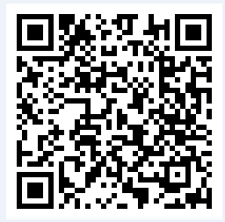

Queries can be directed to: [strydomjf@ufs.ac.za](mailto:strydomjf@ufs.ac.za) or [qpasurvey@ukzn.ac.za](mailto:qpasurvey@ukzn.ac.za)

HSREC reference number: HSSREC/00009154/2025