**University of KwaZulu-Natal's Centre for Civil Society Seminar Series on the State of South Africa's Electricity & Water Service Delivery**

In this seminar series, we engage scholars, activists, and social movements to examine the methods and actions that they have deployed to advocate for equal access to the basic rights of water and energy. We will invite speakers to unpack some of the political, economic, and historical conditions that have contributed to an “unjust”, “unequal” and “racist” water and energy supply.

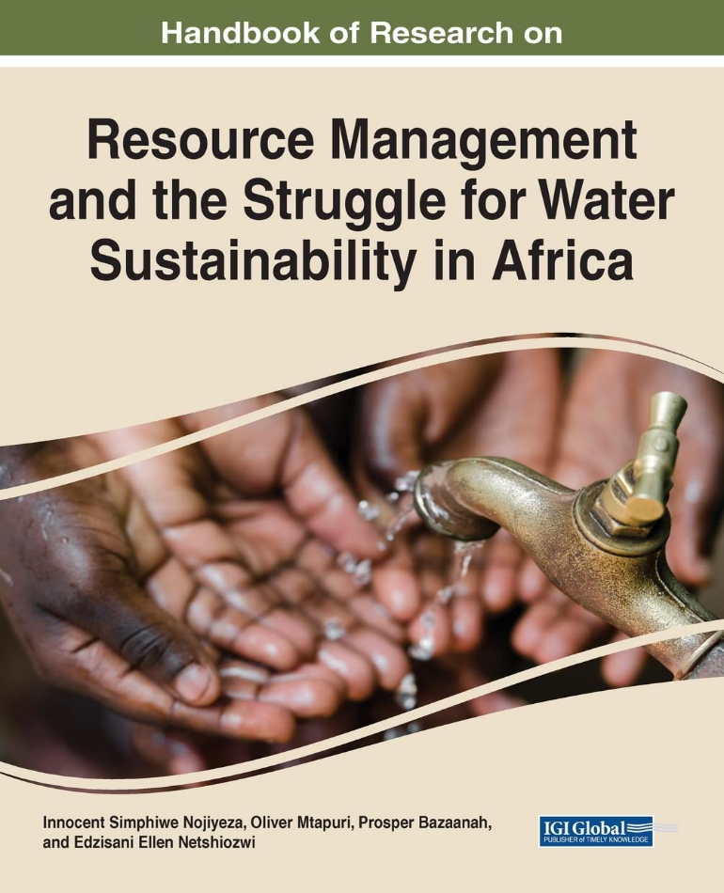

**Seminar: Part 2: Resource Management and the Struggle for Water Sustainability in Africa**

**Date: Thursday, 11 July 2024**

**Time: 16:00-17:00 (South African Time)**

**Zoom Link:** <https://ukzn.zoom.us/j/98555774448?pwd=32xGBvkoNGuueVvemKUVSZ5yxbL6bi.1>

**Speakers: Nomfundo Zulu, Edzisani Netshiozwi, Germain Miteu Tshinu, Gratitude Charis, Tariro Kamuti**

**Facilitators: Andries Motau & Danford Chibvongodze**

**Topic:** In the second part of this seminar, contributors to the recently co-edited book titled “Handbook of Research on Resource Management and the Struggle for Water Sustainability in Africa” (2022) present practical examples of integrated water resources management (IWRM) implementation in African countries. Drawing cases from the Democratic Republic of Congo and South Africa, the authors examine how water resources management in the intersects with the contemporary issues of alternative energy, sanitation and community-based climate change adaptation. The emphasises on the importance of institutions in driving water, sanitation and energy agenda, policy processes and reconfigurations in Sub-Saharan Africa. The synergy of efforts of the state, the private sector and civil society groups in the management of water, sanitation and renewable energy is critical for driving sectoral, structural, and institutional reforms

**Speakers:**

**Tariro Kamuti**- Centre for Gender and African Studies, University of Free State, South Africa.

**Gratitude Charis**- Botswana International University of Science and Technology, Botswana.

**Edzisani Netshiozwi-** The Management College of Southern Africa, South Africa.

**Nomfundo Zulu-** University of Zululand, South Africa.

**Germain Miteu Tshinu-** University of Zululand, South Africa.