**Centre for Civil Society - Seminar on Peacemaking and Peacebuilding in South Africa**

The South African National Peace Accord (NPA) marked an important transitional phase. Signed by the ANC Alliance, Government, Inkatha Freedom Party and other political and labour organizations on 14 September 1991, the parties agreed in the NPA on the common goal of a united, non-racial democratic South Africa and provided practical means. In this seminar, we delve into Liz Carmichael's current book, “Peacemaking and Peacebuilding in South Africa” to get the first full account of the Accord and how it worked as a key transitional instrument. The book is available at the special price of R350 from Mzansi Books: <https://www.mzansibooks.co.za/products/peacemaking-and-peacebuilding-in-south-africa-the-national-peace-accord-1991-1994>

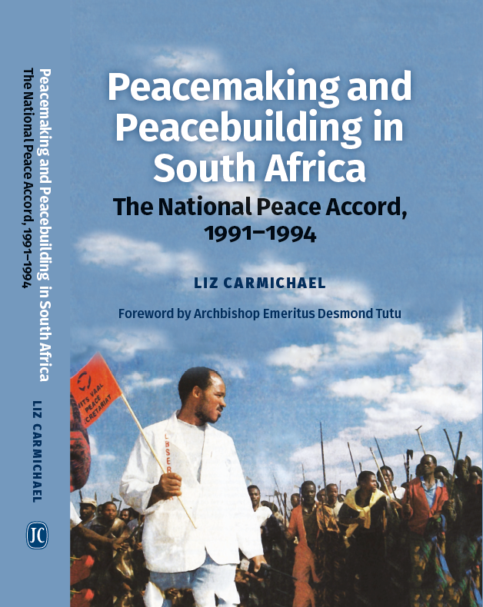

**The UKZN Centre for Civil Society is inviting you to a Zoom Session of the CCS Webinar Series**

**Please note changing times to accommodate speakers from international time zones:**

**Facilitator: Danford Chibvongodze**

**Seminar:** Empowering the People: Civil Society and the National Peace Accord, 1991-1994

**Speaker:** Liz Carmichael

**Date & Time:** Thursday, 14 August 2025, 15:00-16:00 (SA Time)

Zoom Link:<https://ukzn.zoom.us/j/92396914228?pwd=HKqIsEcNc0bKvaaDgCyMzXGqd3BwEH.1>

**Topic:** In 1991, amid distrust and violence, South Africa's political leaders were brought together by a remarkable facilitating group of church and business leaders, to negotiate peace agreements. These became the National Peace Accord, South Africa’s first truly multiracial and multiparty compact.  The Accord provided codes of conduct for political organizations and security forces, and created national, regional, and local peace committees where civil society, political reps, and security forces all worked together, meeting each other for the first time. The peace structures were mandated to resolve conflicts and end local violence, investigating its causes with the Goldstone Commission; they monitored events, helped revolutionise police-community relations, and pioneered an inclusive style of socio-economic reconstruction. After the 1994 Election the peace structures were closed, and civil society was de-mobilized. Arguably this was premature. Can the National Dialogue create a new inclusive vision and find fresh spaces for action?

**Speaker Bio:**

Revd Dr Liz Carmichael MBE is an Emeritus Fellow in Theology at St John's College, Oxford, and co-convenes OxPeace (the Oxford Network of Peace Studies). She was a doctor at Baragwanath Hospital, Soweto 1975-1981, then gained a first-class degree and doctorate in Theology from Oxford, worked in the Anglican Diocese of Johannesburg 1991-1996, was ordained priest in 1992 and appointed MBE in 1995. She served on the Alexandra Local Peace Committee, trained peace monitors, and facilitated reconstruction and development, 1992-1996. She was Chaplain and Tutor in Theology at St John’s 1996-2011, and Emeritus Research Fellow, researching the National Peace Accord, 2011-2023. Liz keeps a base in Johannesburg and wishes every success to the National Dialogue, to bring fresh vision and real action!

