

# CLMS STUDENT SUPPORT SERVICES (SSS)



**ALL CLMS STUDENTS ARE WELCOME**

Stress management Workshop

Meeting ID: 985 3112 3421

Passcode: 097299

THURSDAY 27 MARCH 2025 12H00 – 13H00 (SAST)

**GREAT OPPORTUNITY TO:**

* **Learn how to manage stress better and take care of your mental well-being.**
* **Learn practical coping techniques and how to recognize burnout.**
* **Learn ways to build resilience.**
* **Learn how to balance academics, relationships, and self-care without feeling stretched too thin.**

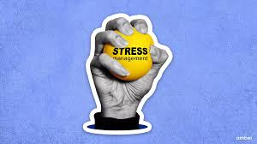

**TO FIND OUT MORE, PLEASE CONTACT:**

[**https://stuukznac.sharepoint.com/sites/clmsstudentsupport**](https://stuukznac.sharepoint.com/sites/clmsstudentsupport)

**Miss Snethemba Gwambe**

[**GwambeS1@ukzn.ac.za**](mailto:GwambeS1@ukzn.ac.za)

**INSPIRING GREATNESS**