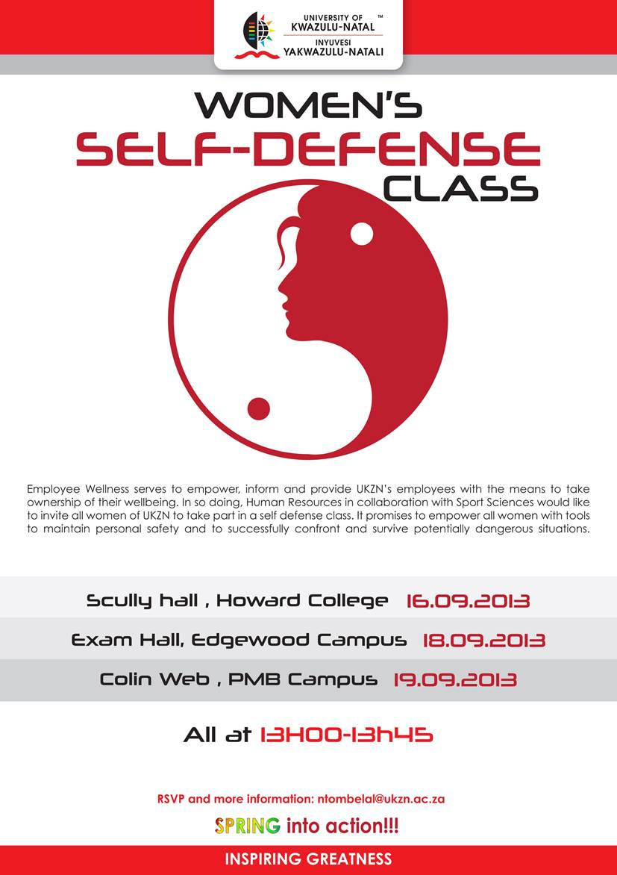**COLLEGE OF HEALTH SCIENCES:**

**STUDENT SUPPORT SERVICES & TEACHING AND LEARNING OFFICE**

**2018 ACADEMIC MENTORS – AMS PROGRAMME**

**FIXED TERM CONTRACT POSITION**

**Reference: CHS Academic Mentor/2018 Closing date: 30 November 2017**

Academic Mentors are key role players in the College of Health Sciences “Academic Monitoring and Support Programme”. The incumbent will provide academic mentorship to undergraduate students, facilitate study groups and offer peer facilitated sessions as required. The incumbent will report to the Discipline Academic Development Officer.

**Minimum Requirements**:

* Must be a registered student in the discipline applying to
* Good academic performance
* Good grasp and understanding of academic content
* Improved learning skills and strategies
* Knowledge of group facilitation
* Good time management skills
* Good leadership skills
* Good communication and interpersonal skills
* Good report writing skills
* Ability to work in a team

Advantages:

* Previous experience in mentorship or tutoring

**Applicants are required to submit a 1 page CV together with a brief motivation telling us how you meet the minimum requirements**

Enquiries and applications regarding this post are to be directed to the ADO within the relevant school as indicated below, quoting the reference **CHS Academic Mentor/2018** in the subject line.

|  |  |  |
| --- | --- | --- |
| **DISCIPLINE/SCHOOL** | **ADO Details** | **ADO’S EMAIL ADDRESS** |
| Anatomy | Chantel Jughoo | Jughoo@ukzn.ac.za |
| Audiology | Gugu Madlala | madlalag@ukzn.ac.za |
| MBChB (4 - 6):Clinical Medicine | Mbalenhle Maseko | masekom@ukzn.ac.za |
| MBChB (1 - 3): Clinical Medicine | Zinhle Mvelase | Mvelasez@ukzn.ac.za |
| Dental Therapy and Oral Hygiene | Nomfundo Zulu | Zulun5@ukzn.ac.za |
| Occupational Therapy | Andiswa Mbatha | Mbatha@ukzn.ac.za |
| Optometry | Gugu Madlala | madlalag@ukzn.ac.za |
| Pharmacy | Nomfundo Mchunu | Mchunun1@ukzn.ac.za |
| Physiology | Cassandra Subiah  Khayelihle Makhathini | Subiah@ukzn.ac.za  [Makhathinik@ukzn.ac.za](mailto:Makhathinik@ukzn.ac.za) |
| Physiotherapy | Andiswa Mbatha | Mbatha@ukzn.ac.za |
| Speech-Language Pathology | Nomfundo Zulu | Zulun5@ukzn.ac.za |
| Sports Science | Nosipho Silindile Shange | shangen@ukzn.ac.za |
| Nursing | Lungelo Masinga | Masingal2@ukzn.ac.za |