Connecting to the UKZN network via the SSL VPN for **WINDOWS USERS**

1. Access the VPN web portal at <https://vpn.ukzn.ac.za/>
2. Login with your UKZN credentials
3. Download and install the plugin for the SSL-VPN

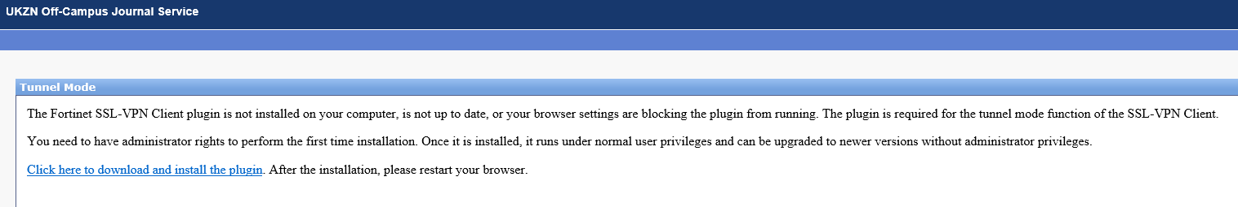

1. click on "Run as administrator"  
     
   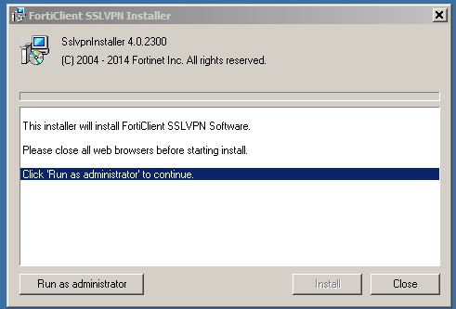
2. After the installation has completed, restart your browser.
3. Access the VPN web portal at <https://vpn.ukzn.ac.za/>
4. Login with your UKZN credentials.
5. In the Tunnel Mode Section, Click on connect.  
     
   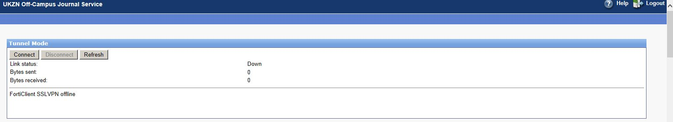
6. You will now be connected to the UKZN network via the SSL VPN client, and once connected you need to open another tab and go to <http://library.ukzn.ac.za> to access library journals (there is no need to click off campus access). You will be able to access journals as long as you stay connected on SSL VPN. Once done please go back to Tunnel Mode and Disconnect.