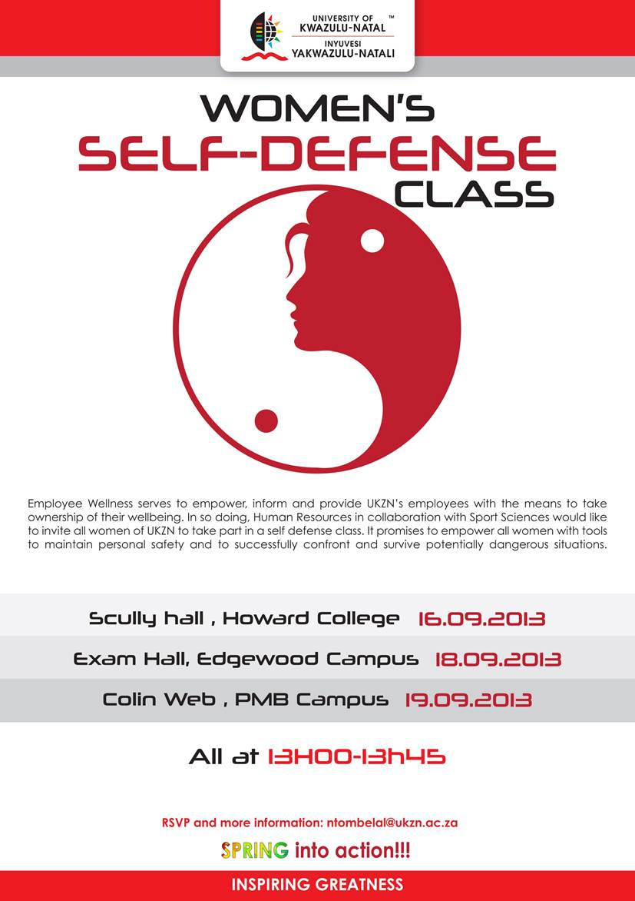**COLLEGE OF HEALTH SCIENCES**

**STUDENT SUPPORT SERVICES & TEACHING AND LEARNING OFFICE**

**AMS PROGRAMME - 2018 PEER WELLNESS MENTOR**

**FIXED TERM CONTRACT POSITION**

**Reference: CHS Peer Wellness Mentor/2018 Closing date: 30 November 2017**

The College of Health Sciences, Student Support Services and Office of the Dean: Teaching and Learning seek to employ Peer Wellness Mentors for the 2018 academic year. The successful incumbents will assume duty in mid-January 2018.

**Minimum requirements:**

* Registered for their 2nd or 3rd year of study in 2018 in the respective College of Health Sciences disciplines with a good academic record**.**
* Must have up to 5½ ***hours per week*** available to devote to the Peer Wellness Mentor Programme.
* Peer Wellness Mentors must be available to Mentees from January.

**Key Functions**

* Provide basic support and guidance to 1st entry students.
* Refer urgent matters to the Student Support Services for intervention.
* Attend compulsory 2 day training.
* Attend compulsory monthly supervision and debriefing sessions.
* Maintain weekly contact with Mentees.
* Document and submit monthly statistics of contact with mentees

**Skills Required**

* Good communication and interpersonal skills.
* Willing to work with and appreciate students from diverse backgrounds.
* Be reliable and committed to the mentees they serve.
* Maintain strict confidentiality.
* Display good leadership skills.
* Be self-disciplined.

**Applicants are required to submit a 1 page CV together with a brief motivation telling us why you would be a suitable Peer Wellness Mentor.**

Enquiries and applications regarding this post are to be directed to the ADO within the relevant school as indicated below, quoting the reference **CHS Peer Wellness Mentor/2018** in the subject line.

|  |  |  |
| --- | --- | --- |
| **DISCIPLINE/SCHOOL** | **ADO Details** | **ADO’S EMAIL ADDRESS** |
| Anatomy | Chantel Jughoo | Jughoo@ukzn.ac.za |
| Audiology | Gugu Madlala | Zulun5@ukzn.ac.za |
| MBChB: Clinical Medicine | Zinhle Mvelase | Mvelasez@ukzn.ac.za |
| Dental Therapy and Oral Hygiene | Nomfundo Zulu | Zulun5@ukzn.ac.za |
| Occupational Therapy | Andiswa Mbatha | Mbatha@ukzn.ac.za |
| Optometry | Gugu Madlala | madlalag@ukzn.ac.za |
| Pharmacy | Nomfundo Mchunu | Mchunun1@ukzn.ac.za |
| Physiology | Cassandra Subiah  Khayelihle Makhathini | [Subiah@ukzn.ac.za](mailto:Subiah@ukzn.ac.za)  [Makhathinik@ukzn.ac.za](mailto:Makhathinik@ukzn.ac.za) |
| Physiotherapy | Andiswa Mbatha | Mbatha@ukzn.ac.za |
| Speech-Language Pathology | Nomfundo Zulu | Zulun5@ukzn.ac.za |
| Sports Science | Nosipho Silindile Shange | shangen@ukzn.ac.za |
| Nursing | Lungelo Masinga | Masingal2@ukzn.ac.za |