**UKZN's Centre for Civil Society Seminar Series on the State of South Africa's Electricity & Water Service Delivery**

In this seminar series, we engage scholars, activists, and social movements to examine the methods and actions that they have deployed to advocate for equal access to the basic rights of water and energy. We will invite speakers to unpack some of the political, economic, and historical conditions that have contributed to an “unjust”, “unequal” and “racist” water and energy supply.

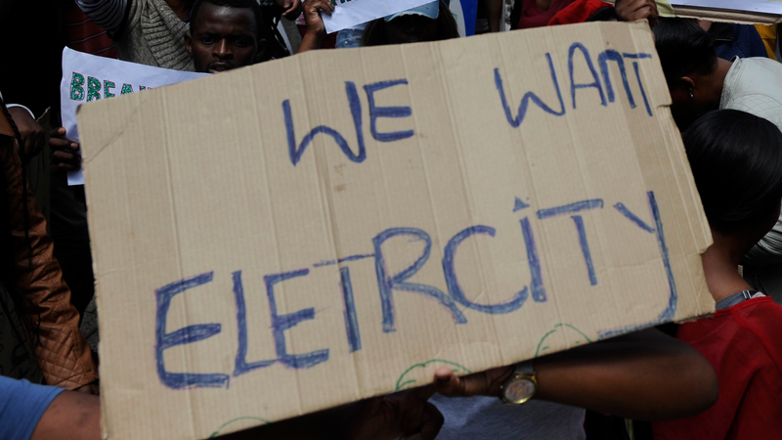

Picture: Bhekikhaya Mabaso African News Agency (ANA)

**Seminar: South Africa’s Energy Racism**

**Date: Thursday, 16 May 2024**

**Time: 16:00-17:00 (SA Time)**

**Zoom Link:** <https://ukzn.zoom.us/j/95164561962?pwd=YjlpZkZ3QVVTYnlkRkg3UnMzYjN1UT09>

**Speaker: Trevor Ngwane**

**Facilitators: Andries Motau & Danford Chibvongodze**

**Topic:**

The struggle for safe, reliable, and affordable energy for all took a great knock with the advent of the energy crisis in South Africa. For working class communities this was a double blow because they had long been experiencing power cuts and supply disruptions even before load shedding started. The worst part is that load shedding itself targeted and overburdened black working-class townships, villages and shack settlements through a special additional programme called ‘load reduction’ implemented by Eskom nationally. Research conducted at the Centre for Sociological Research and Practice at the University of Johannesburg revealed this added injustice and received the attention and outrage of the public through media channels. The researchers named it energy racism.

**Speaker’s Bio**

Trevor Ngwane is a scholar activist who has worked in trade unions, community organisations and political formations. He continues to participate in campaigns for access to basic services and against xenophobia in and around Soweto where he lives. He obtained his MA at UKZN attached with the Centre for Civil Society and his PhD at UJ. He is the author of Amakomiti: Grassroots Democracy in South African Shack Settlements (2021), and co-editor with Malehoko Tshoaedi of The Fourth Industrial Revolution: A Sociological Critique (2021). He is a senior lecturer at the UJ Department of Sociology and outgoing director of the UJ Centre for Sociological Research and Practice.