Step 1 :
In your browser type: https://learn.ukzn.ac.za/
Step2:
Double click on Login at the top right corner of the page
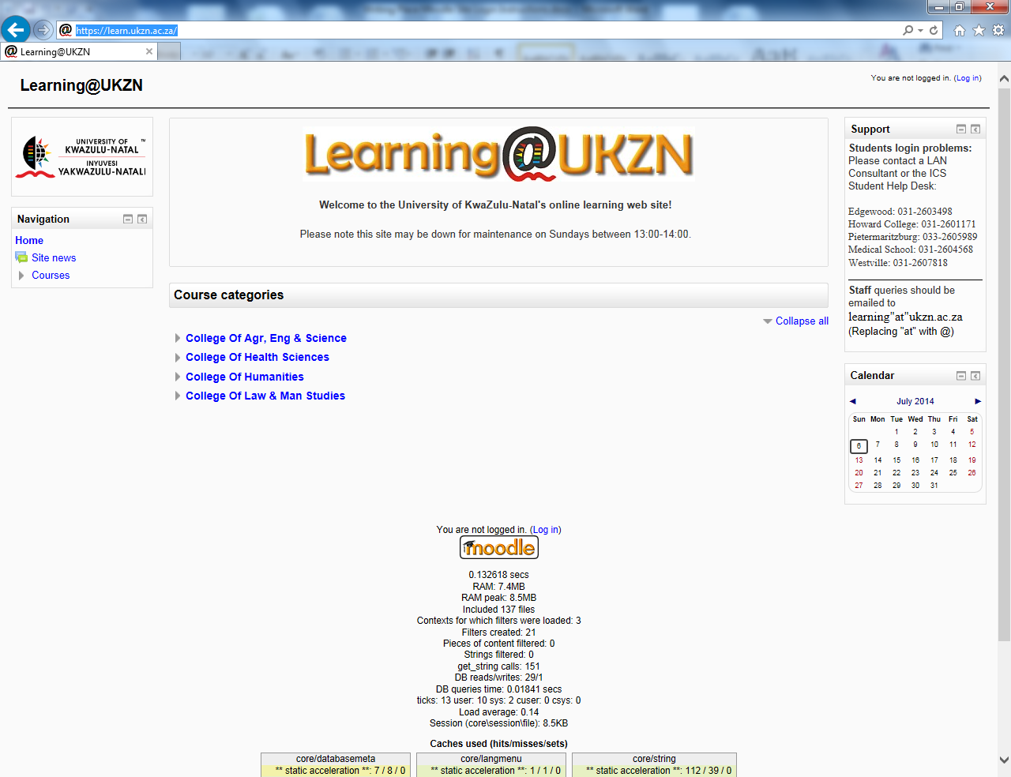
Step 3:
Enter your details i.e. Student Number as Username and Password (The same Password that you use to login into the LAN). You will then get to the learn.ukzn.ac.za main page.
Step 4:
Under “Search courses”, type Writing place and then click go
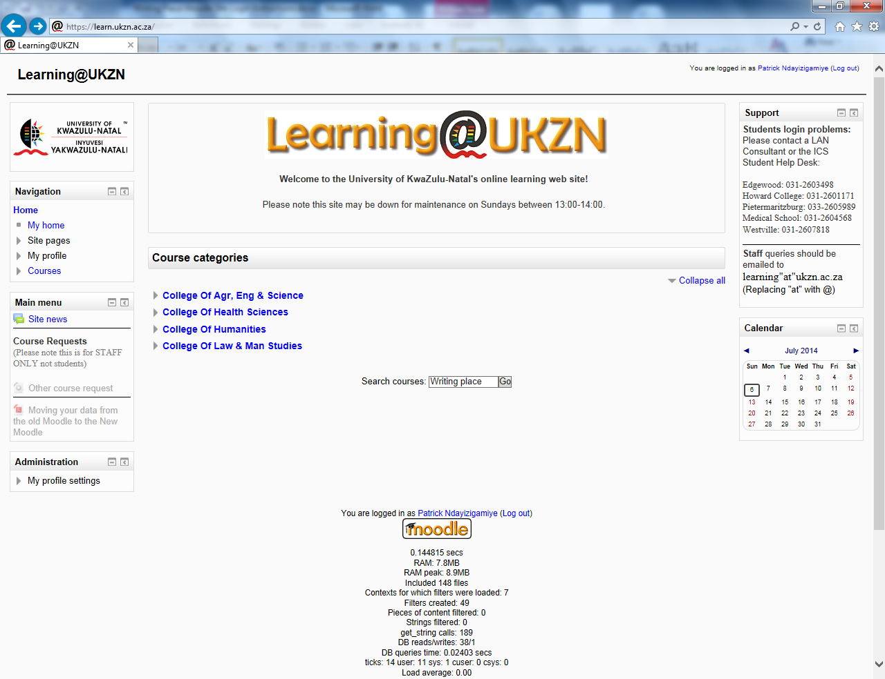

Step 5:
Click on 2014 writing place as shown in the screen shot below
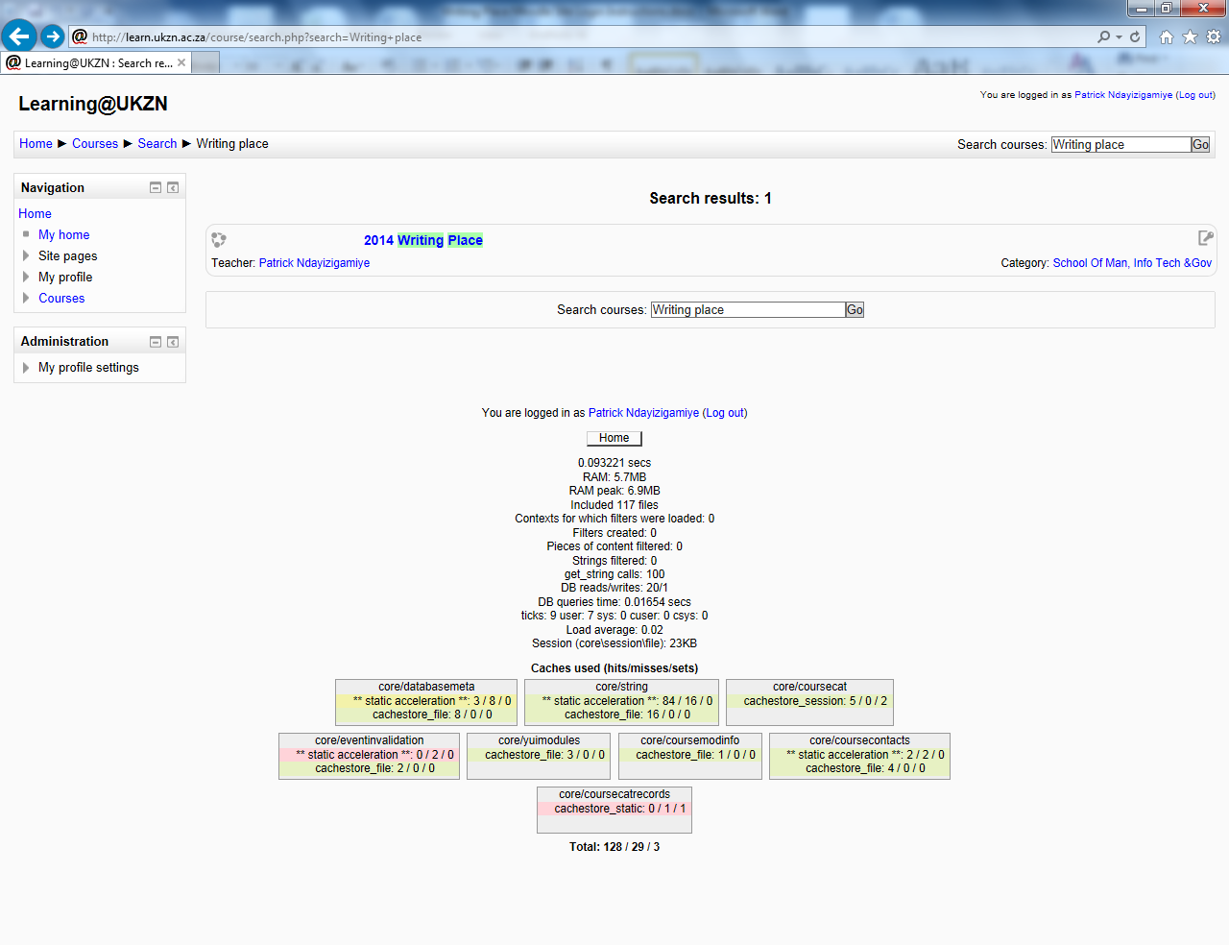

Step 6:
Click in the textbox next to enrolment keyand type wp2014. Then Click Enrol me button
N.B.: wp2014 is the enrolment key for the writing place Moodle site.

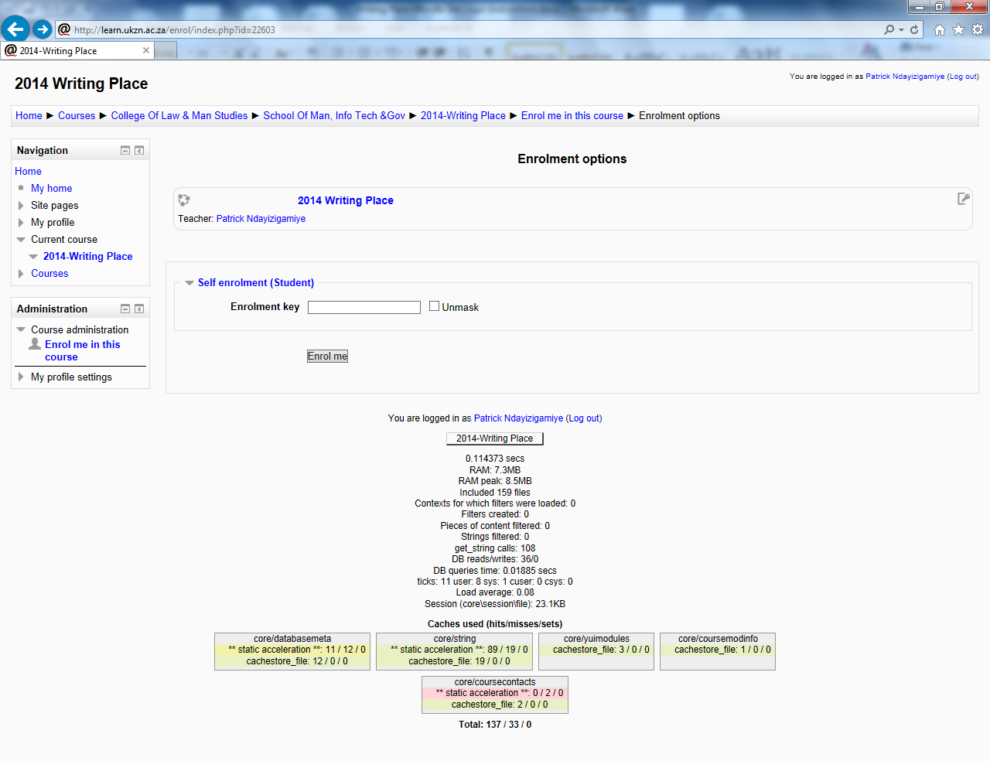

Step 7
Finally you have access to the website. The website has 4 sections:
- Discussion Forum:
This is where you can post a comment. Please note that your comments should only be limited to academic discussion. Also note that your comments will be seen by anyone who subscribed to the site
- Notices:
This section is reserved for any announcements concerning the writing place. Please check it regularly for any update such as change of the Writing Place Opening/Closing times, change of tutors’ consultation timetable, etc…
- Writing place documents:
This section contains online materials such as the Referencing Guide, Referencing Tutorial and a Practical Guide to Academic Writing
- Online feedback
This section is reserved for your comments on the level of satisfaction from the service (s) you received from the writing place. Please note that we need your feedback so that we may enhance the manner in which we deliver our services to you.

THANK YOU

