

To the University community for your support and generous donations of 50 book-ends and nearly 500 books, and for assisting with moving the large display shelves for the

Grange Primary School library in Pietermaritzburg.

The official opening of the library was a huge success on Mandela Day, 18 July 2024.

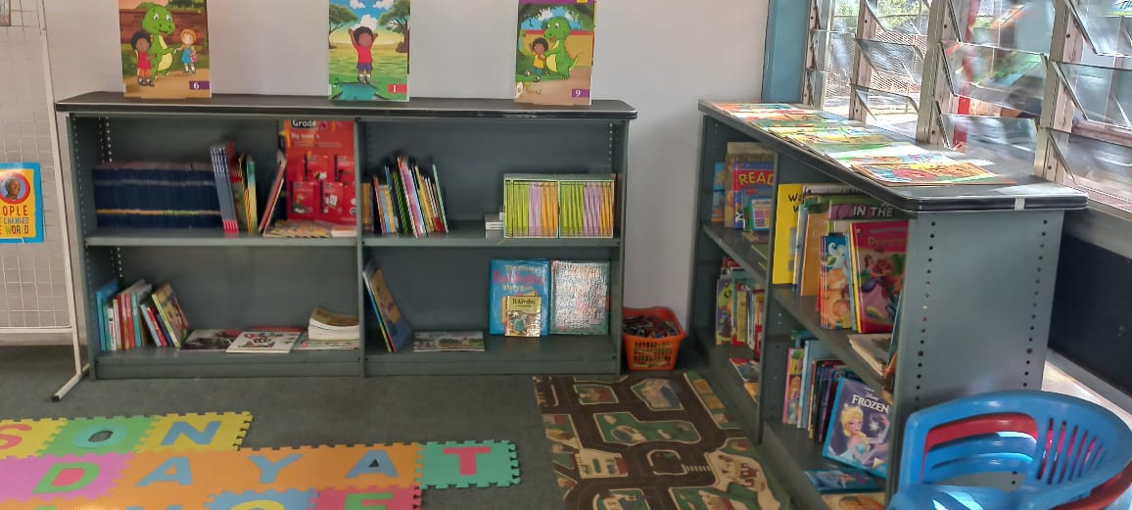

Our combined team effort has resulted in a library that will benefit many generations.

“When we read we are able to travel to many

places, meet many people and understand the world.”

Nelson Mandela

We appreciate your support.

Regards,

The UKZN PMB Library Services Team.