**cid:image001.png@01DABB23.04E95160 **

**UKZN's Centre for Civil Society Seminar Series on the State of South Africa's Electricity & Water Service Delivery**

In this seminar series, we engage scholars, activists, and social movements to examine the methods and actions that they have deployed to advocate for equal access to the basic rights of water and energy. We will invite speakers to unpack some of the political, economic, and historical conditions that have contributed to an “unjust”, “unequal” and “racist” water and energy supply.

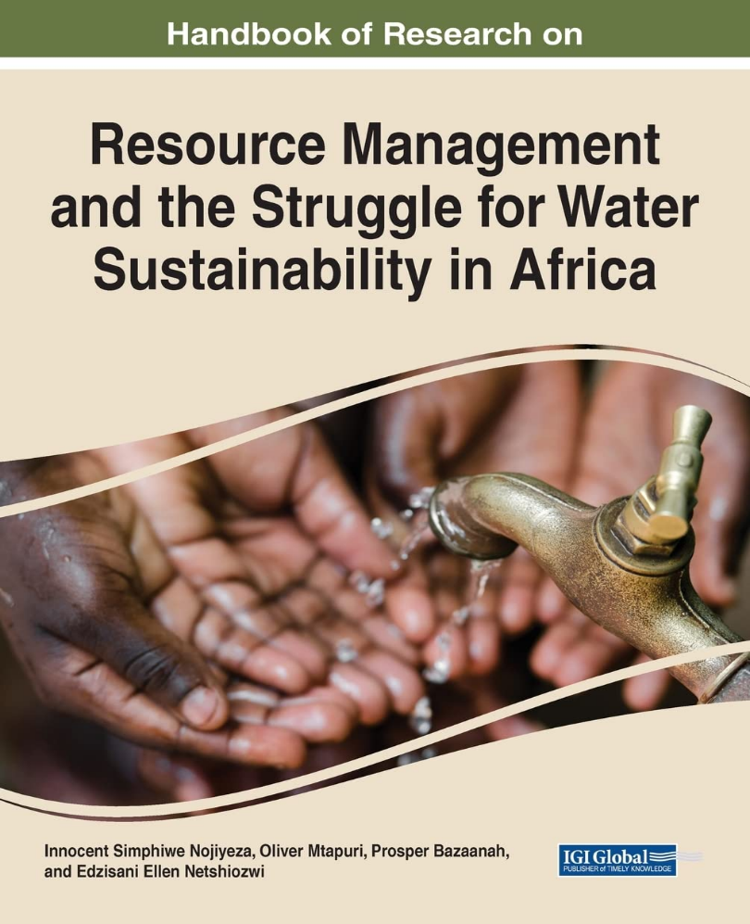

Image source: Amazon

**Seminar:** **Resource Management and the Struggle for Water Sustainability in Africa**

**Date: Thursday, 04 July 2024**

**Time: 16:00-17:00 (SA Time)**

**Zoom Link:** <https://ukzn.zoom.us/j/98966347497?pwd=xeX2ZPW5WIhXQpTidbyLbPtZV2mYEO.1>

**Speaker: Simphiwe Nojiyeza**

**Facilitators: Andries Motau & Danford Chibvongodze**

**Topic:** In this seminar, Simphiwe Nojiyeza discusses his recently co-edited book titled “Handbook of Research on Resource Management and the Struggle for Water Sustainability in Africa” (2022). The book presents practical examples of integrated water resources management (IWRM) implementation in African countries. Drawing cases from Zimbabwe, Democratic Republic of Congo, Malawi, South Africa and Ghana it examines how water resources management in the intersects with the contemporary issues of alternative energy, sanitation and community-based climate change adaptation. The emphasises on the importance of institutions in driving water, sanitation and energy agenda, policy processes and reconfigurations in Sub-Saharan Africa. The synergy of efforts of the state, the private sector and civil society groups in the management of water, sanitation and renewable energy is critical for driving sectoral, structural, and institutional reforms

**Speaker’s Bio**

Simphiwe Nojiyeza is currently the Professor in the Business School of the Durban University of Technology, and recently worked as a Research Professor at the North- West University’s Population Studies and Health Research Centre and previously (1 June 2018 to 9 June 2023) he was a Head of Department, Senior Lecturer and Associate Professor at the University of Zululand’s Department of Anthropology and Development Studies. He has over two decades of environmental and climate change activism as chair of the KZN Environmental Justice Networking Forum (mid-1990s), chair of Earthlife Africa Durban (early 2000s), board member of Earthlife Africa Johannesburg’s Sustainable Energy and Climate Change Partnership (SECCP) (early 2000s to date) and founder-member of the South African Water Caucus. Prof Simphiwe Nojiyeza holds a B.A(History and Education) from UNISA, Postgraduate Certificate in Management, Postgraduate Diploma in Management Studies, and Master of Business Administration from the Management College of Southern Africa (MANCOSA) and a Doctor of Philosophy degree in Development Studies from UKZN.

