**Centre for Civil Society - Special Seminar Series: Thought for Food**

The Thought for Food seminar series examines challenging themes in food studies. If we are indeed what we eat, how do the lies and half-truths we consume shape our identities and behaviours? Given our colonial history, what could a just food system looks like, considering how the intersections of gender, race, class, age, and location affect access to healthful food? Are there concrete examples that we can learn from one another about food, its production and consumption, its circuits, and impact? The goal of these dialogs and presentations is to provide a platform for students, academics, activists, and policy makers to learn from ongoing work to foster more sustainable food production systems in Africa.

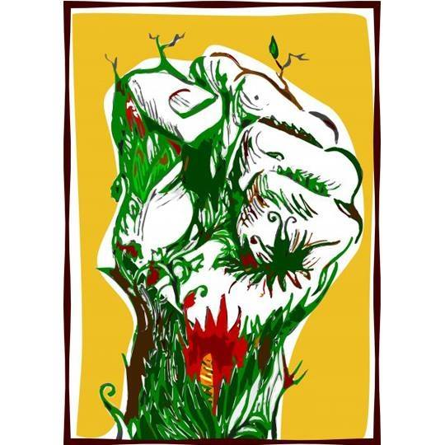

**The UKZN Centre for Civil Society is inviting you to a Zoom Session of the CCS Webinar Series**

**Please note changing times to accommodate speakers from international time zones:**

**Seminar:** Food Movements Unite! Food sovereignty, the agrarian question, and the contours of organising from below in the South African food system

**Speaker:** Andrew Bennie

**Date & Time:** Thursday, 03 July 2025, 15:00-16:00 (SA Time)

Zoom Link:<https://ukzn.zoom.us/j/92908786789?pwd=2oeB850xoozkBKX2QSl6xvX5lGbTFU.1>

**Speaker Bio:**

Andrew Bennie is a Senior Researcher in Climate Policy and Food Systems at the Institute for Economic Justice in Johannesburg. He has extensive background in academic and civil society research, organising, and activism. He previously worked as a researcher, organiser and popular educator with township and rural organisations, and coordinated national food justice campaigning. He has also worked in research and advocacy in the broader African food sovereignty movement. Andrew has an MA in Development and Environmental Sociology, and a PhD in Sociology on food politics from Wits. His research expertise is in political economy and ecology, land and agrarian studies, food systems and climate justice. He is passionate about using his capacities (including writing and photography) towards collective struggles for justice and equality.