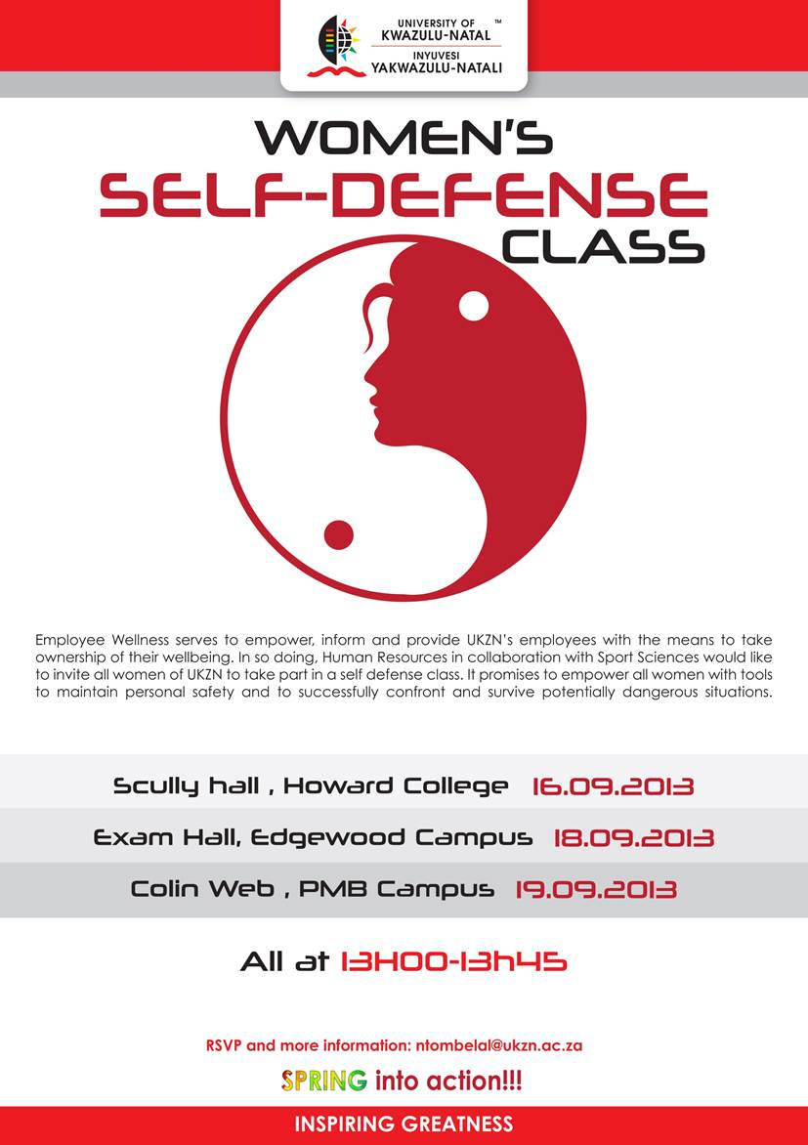****

**COLLEGE OF HEALTH SCIENCES**

**STUDENT SUPPORT SERVICES**

**MONEY MANAGEMENT WORKSHOP**

**FOR FUNDED STUDENTS**

**PROGRAMME**

|  |  |  |
| --- | --- | --- |
| Welcome, Meet and Greet | 4.30 – 4.35 p.m. | Student Counsellors:   * Wulli Thaver * Suzanne Stokes |
| Experiences and Expectations of Workshop | 4.40 – 4.50 p.m. |
| Managing your funding | 4.55 – 5.55 p.m. |
| Funding Office | 6.00 ~ 6.15 p.m. | Funding Advisors:   * Paseka Nkhoesa * Musa Gumbi |
| Questions and Answers | 6.20 – 6.30 p.m. | Student Counsellors:   * Wulli Thaver * Suzanne Stokes |
| Evaluation of Workshop |



**@ NRMSM**

**Friday, 29 July 2016**

**4.30 to 6.30 p.m.**

**Susser and Stein**

**KRith Building**

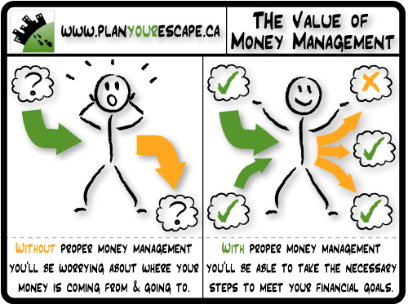**AND**

**@ Howard College Campus**

**Tuesday, 2 August 2016**

**4.30 to 6.30 p.m.**

**Classroom 1, 5th Floor,**

**Desmond Clarence Building**