higher education & training
Department:
Higher Education and Training
REPUBLIC OF SOUTH AFRICA

Private Bag X174, PRETORIA, 0001, 123 Francis Baard Street, PRETORIA, 0002, South Africa Tel: (012) 312 5911, Fax: (012) 321 6770
Private Bag X9192, CAPE TOWN, 8000, 103 Plein Street, CAPE TOWN, 8001, South Africa Tel: (021) 469 5175, Fax: (021) 461 4761
Enquiries: Ms J. Ngcobo, Tel: 012 312 5094; E-mail: ngcobo.j@dhet.gov.za

SCHOLARSHIPS FOR STUDIES IN CHINA, RUSSIA, SWEDEN AND HUNGARY

The Department of Higher Education and Training (DHET) would like to inform you that applications for scholarships to study in China, Russia, Sweden and Hungary from the 2018/19 academic year are now open. It would be appreciated if you could share information about these opportunities with your students and staff. Information about these scholarships is briefly summarized below. More information is attached and can also be viewed on our website: www.internationalscholarships.dhet.gov.za. The focus for all our international scholarship programmes is on postgraduate studies, although there are a limited number of opportunities for undergraduate studies available.

Chinese Government Scholarship
The DHET is facilitating applications for the Chinese Government Scholarship for South Africans to study in China. Opportunities are available at Master's, PhD and Postdoctoral levels as well as for non-degree Chinese language studies. Bachelor's degree applicants must be fluent in Chinese as all Bachelor's level courses under this scholarship programme are taught in Chinese. Master's and PhD programmes may be taught in English at certain universities. All applicants must apply directly to their university of choice in China as well as submit an application form and supporting documents to the DHET. PhD applicants should make contact with a potential supervisor in advance. The deadline for applications is 7 March 2018.

Russian Government Scholarship
The Department is responsible for nominations for this scholarship, which may be awarded for undergraduate or postgraduate studies in identified fields. Most programmes are taught in Russian and therefore a language preparatory course for one year is compulsory before pursuing major studies. The deadline for applications to the DHET is 16 February 2018.

Higher Education and Training • Hoer Onderwys en Opleiding • lmfundvo Lephakeme Nekucecesha • lfundo Ephakemeko Nebandulo IMfundo Ephakeme Nokuqeqesha • IMfundo ePhakamileyo noQeqesho • Dyondzo ya le Henhla na Vuleteri • P1unzo ya Ntha na Vhugudisi Thuto ya Godimo le Tlhahlo • Thuto e Phahameng le Thupelo • Thuto e Kgolwane le Katiso

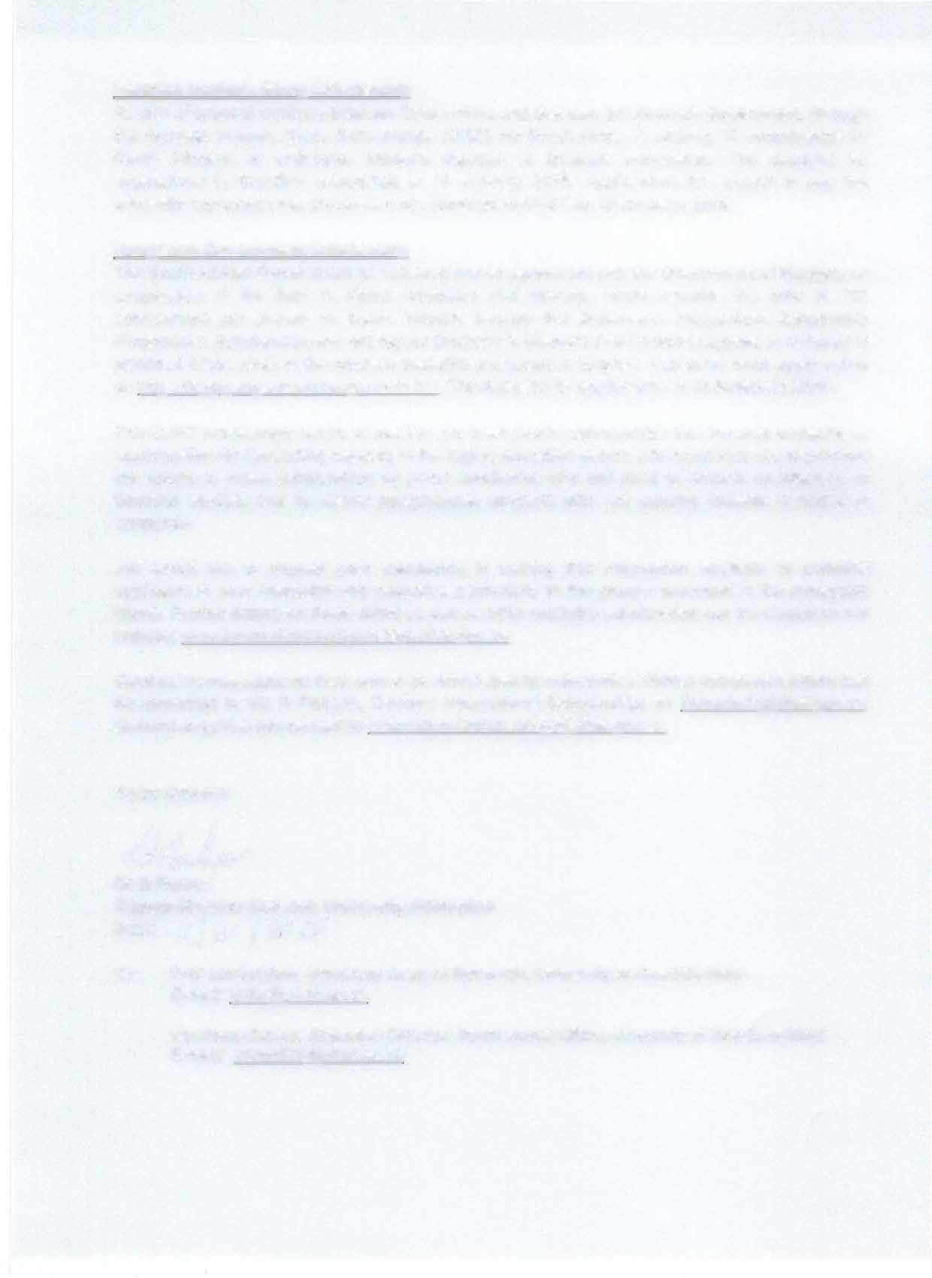
Swedish Institute Study Scholarship
As part of bilateral relations between South Africa and Sweden, the Swedish Government, through the Swedish Institute Study Scholarships (SISS) for South Africa, is offering 10 scholarships for South Africans to undertake Master's degrees at Swedish universities. The deadline for applications to Swedish universities is 15 January 2018. Applications for support to pay the university application fee should also be submitted to DHET by 15 January 2018.

Hungarian Government Scholarship
The South African Government has entered into an agreement with the Government of Hungary on cooperation in the field of higher education and training, which includes the offer of 100 scholarships per annum to South Africans through the Stipendium Hungaricum Scholarship Programme. Scholarships are offered for Bachelor's, Master's and Doctoral degrees in Hungary in identified fields. Most of the courses available are taught in English. Applicants must apply online at: https://apply.stipendiumhungaricum.hu/. The deadline for applications is 16 February 2018.

The DHET increasingly seeks to position the international scholarships that become available as opportunities for developing capacity in the higher education sector. We would thus like to promote the uptake of these scholarships by junior academics who still need to embark on Master's or Doctoral studies, and by senior postgraduate students who are aspiring towards a career in academia.

We would like to request your assistance in making this information available to potential applicants in your institution and networks, particularly to the groups described in the paragraph above. Further details on these offers as well as other available scholarships can be viewed on our website: www.internationalscholarships.dhet.gov.za.

Candidates may apply on their own or be nominated by universities. Official nomination letters can be forwarded to Ms R Roberts, Director: International Scholarships on Roberts.R@dhet.gov.za. General enquiries can be sent to internationalscholarships@dhet.gov.za.

Yours sincerely

IV�

Dr D Parker
Deputy Director General: University Education Date: / / / () ( / 2(J
f<i

