**Civil Society in South Africa:** **A Shrinking Space?**

**Sonke Gender Justice & Social Justice Coalition**

A number of international studies have noted a ‘shrinking space’ for civil society. This has been attributed to curtailing civil society organisation activities, increased regulation, repression and restrictions owing to increased and complicated reporting requirements. South African studies have echoed this trend noting threats of closer regulation, findings of pre-emptive repression of protest, intimidation of activists and the framing of social movements and some NGOs as ‘counter revolutionary’.

This seminar series seeks to disseminate findings from a Centre for Civil Society NRF funded research study. The study focused on how the ‘shrinking space’ of civil society has impacted on the functioning of social movements and NGOs in South Africa in terms of their framing strategies, their ability to mobilise and their inclination to link with the grass roots avoiding processes of ‘NGOization’. The series incorporates eight case studies of foremost social justice movements (civil society organisations) in South Africa: Black Sash, Equal Education, Land Access Movement of South Africa, the Right to Know Campaign, Section 27, Social Justice Coalition Treatment, Sonke Gender Justice and the Treatment Action Campaign.

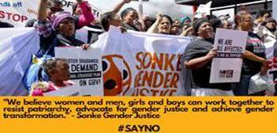

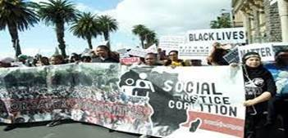

**Date: Tuesday 30 April 2024**

**Time: 4:00pm – 5:15pm (SA time)**

**Zoom Link**: <https://ukzn.zoom.us/j/99575721975?pwd=U0o1OFhocE9zRXI4ZzNTVzU2MEZydz09>

**Speaker:** **Vuyiseka Dubula**

**Speaker Bio:** Vuyiseka is currently the Global Fund’s Head of Community, Rights and Gender Department. She is the former African Advocacy & Partnerships, at the Stephen Lewis Foundation. She is the former Director of the Africa Centre for HIV/AIDS Management at the Stellenbosch University. She has been living openly with HIV for more two decades and has been a leader in the people living with HIV movement throughout this time. Vuyiseka was Executive Director of the Treatment Action Campaign (TAC) from 2007-2013. She is currently a commissioner on the O’Neill-Lancet Global Commission on Racism, Structural Discrimination and Global Health for 2022-2025 period. She has served on the South African National AIDS Council and was a founder of the Activist Centre for Education & Development in 2009.