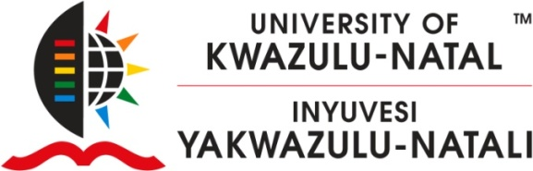

INTEGRATED TALENT MANAGEMENT- INSTITUTIONAL ROADSHOWS 2012

To all Staff:

As you are aware the Integrated Talent Management Policy was approved at Senate in 2011 and the Integrated Talent Management Procedure & Guidelines was approved this year – these have been effective from 01 January 2012.
We wish to cordially invite you to the Integrated Talent Management Roadshows which will be held across the University’s five campuses. Staff will be given an opportunity to engage and ask questions regarding the ITM process and procedure.
The University’s Integrated Talent Management (ITM) process involves identification, mapping, reviewing and development of talent as well as talent planning in order to enable the University of KwaZulu-Natal to achieve institutional objectives.
The objectives of ITM are:
- To attract, nurture and retain key talent as well as develop targeted capabilities and knowledge across UKZN.
- To ensure that all academics are knowledgeable about university research policy, procedures, guidelines and tools to be successful in their research performance through the University Research Induction Programme.
- To ensure that all academics maintain, improve and expand their professional knowledge and skills in order to enhance performance through the University Education Induction Programme.
- To facilitate appreciation of Diversity and encourage Sustainable Inclusion as well as entrench enabling competencies and strategies towards achieving Sustainable Inclusion.
The Roadshows are scheduled as follows.

WESTVILLE  Date : 22 August  Time : 12:00 – 14:00  Venue : Senate Chambers | MEDICAL SCHOOL  Date : 20 August  Time : 14:30 - 16:30 Venue : Steve Biko Theatre

We look forward to your presence and participation at these meetings.
Issued by

Dr. Mojaki Mosia (Executive Director: Human Resources), Professor Renuka Vithal (DVC: Teaching and Learning) and Professor Nelson Ijumba (DVC: Research)

