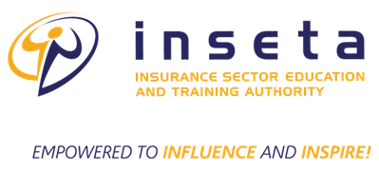
THE PROTECTION OF PERSONAL INFORMATION (POPI) ACT CONSENT FORM
The Protection of Personal Information (POPI) Act 4 of 2013 requires us to inform you how we use, disclose and destroy personal information we obtain from you. We are committed to protecting your privacy as our learner and will ensure that your personal information is used appropriately and according to the applicable law.
I ___________________________________________the undersigned, hereby consent to the follow:
- My personal information may be collected, processed, recorded and used by INSETA/UKZN for the duration of my learning programme.
- INSETA/UKZNmay share my personal information with all the parties involved in the implementation of my learning programme.
Furthermore, I understand that:
- I have the right to access my personal information which INSETA/UKZN and all the parties involved in the implementation of my learning programme holds.
- I have the right to ask INSETA/UKZN and all the parties involved in the implementation of my learning programme to update, correct or delete my personal information on reasonable grounds.
- Should I wish to withdraw my consent to process my personal information, I must do so in writing, addressed to INSETA/UKZN
- Once I withdraw my consent for INSETA/UKZN to process my personal information, I understand that INSETA/UKZN and all the parties involved in the implementation of my learning programme are still obliged under other legislation to keep the information for 5 years after termination of the relationship between INSETA/UKZN all the parties involved in the implementation of my learning programme and myself.
- INSETA/UKZN and all the parties involved in the implementation of my learning programme may disclose my information where they have a duty or a right to disclose in terms of applicable legislation or where it may be necessary under other law.

Signed at _Durban_______on this _15_____day of ___April______2026

________________________
Beneficiary Signature:

