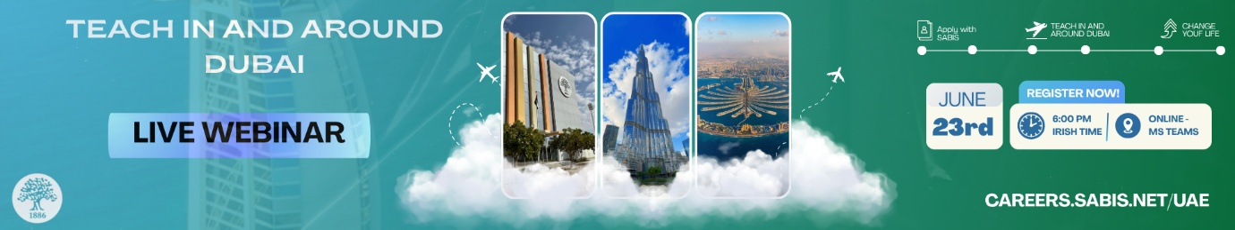
Subject Line: 🌍 One Webinar. Endless Possibilities.
Dear [Name],
Dreaming of teaching abroad? Join our webinar on 23 June and discover how you could start your international teaching career in and around Dubai.
Get your questions answered live by our Recruitment Team and learn what it takes to make the move.
Your package includes:
🏠 Zero rent (accommodation provided) + zero utility bills
💰 A competitive tax-free salary
💡 End-of-service gratuity + optional savings scheme
✈️ Annual return flights + daily school transport
🎓 Complete your PGCE with iQTS while working – a recognised pathway to teach in your country.
💸 Referral bonus + structured annual bonus
📚 Training provided – we prepare you for the classroom

📅 23 June – 6:00 PM Irish Time
🚀 Click here to register

Kind Regards,
Anjie Cooney
Recruitment Department
UAE, Oman, Qatar & Bahrain
To Apply: SABIS® Careers
To View: Our Video Testimonials

Tel +971-6-558 2717


This message contains confidential information intended only for the use of the addressee(s) named above and may contain information that is legally privileged and/or confidential. If you are not the intended recipient of this email, you are hereby notified that reading, disseminating, distributing, or copying of this message, or any attachments hereto, is strictly prohibited. If you have mistakenly received this message, please notify the sender immediately by return email and delete the original message thereafter. Thank you.

