Student Support Services
College of Law & Management Studies
LEARNING STYLE INDICATOR WORKSHOP

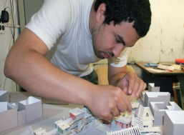

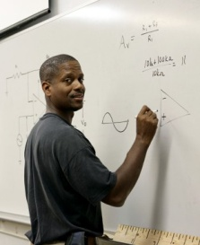

FEELING-ORIENTED
FACT -ORIENTED
ACTION-ORIENTED
OBSERVER-ORIENTED
ACCOMMODATORS
“Jugglers”
DIVERGERS
“The Bright Spark”
CONVERGERS
“The Sniper”
ASSIMILATORS
“The Googler”

Workshop objectives:

By the end of the session, you will be able to:
- Identify your own learning style;
- Understand how you differ from others so that you can approach your work and understand your colleagues in a way that will work best for you.

LEARNING STYLE INDICATOR: INSTRUCTIONS
Tick only one statement per row that most closely describes you. For example number 1 choose either statement A or B, mark with an X in the block. You MUST ANSWER EVERY QUESTION. Please do not skip any.
Total the number of X’s you have in each column and write the total right at the bottom of each column. You should have 9 ticks in total.
 |  |  | A |  |  | B
1 | I often produce off-the-cuff ideas that at first might seem silly or half-baked. |  |  | I’m thorough and methodical
2 | I am normally the one who initiates conversations |  |  | I enjoy watching people
3 | I am flexible and open minded. |  |  | I am careful and cautious
4 | I like to try new and different things without too much preparation. |  |  | I investigate a new topic or process in depth before trying it
5 | I am happy to have a go at new things. |  |  | I draw up lists of possible courses of actions when starting a new project.
6 | I like to get involved and to participate. |  |  | I like to read and observe.
7 | I am loud and outgoing |  |  | I am quiet and somewhat shy.
8 | I make quick and bold decisions. |  |  | I make cautious and logical decisions.
9 | I speak fast, while thinking. |  |  | I speak slowly, after thinking.
A = |  |  |  | B =
Definitions A/B |  |  |  | A - B =
Row 1 |  | Off the cuff – without preparation, not well thought out  Silly – lacking seriousness, wisdom or seriousness  Half baked – incomplete  Thorough - Painstakingly accurate or careful /very careful  Methodical - ordered and systematic habits or behaviour, well thought out
Row 3 |  | Flexible – adaptable, able to change, can be influenced or persuaded  Open-minded – to have or show a mind open to new ideas / willing to consider other ways / perspectives  Careful - guarding against mistakes, harm, or bad consequences by paying close attention to details and by being concerned  Cautious – showing care or attention
Row 8 |  | Bold - Fearless and daring; courageous  Logical - Reasoning or capable of reasoning in a clear and consistent manner

Tick only one statement per row that most closely describes you. For example number 1 choose either statement A or B, mark with an X in the block. You MUST ANSWER EVERY QUESTION. Please do not skip any.

Total the number of X’s you have in each column and write the total right at the bottom of each column. You should have 9 ticks in total.
 |  | C |  | D
1 | I ask probing questions when learning a new subject. |  | I am good at picking up hints and techniques from other people.
2 | I am rational and logical. |  | I am practical and down to earth.
3 | I plan events down to the last detail. |  | I like realistic, but flexible plans.
4 | I like to know the right answers before trying something new. |  | I try things out by practicing to see if they work.
5 | I analyse reports to find the basic  assumptions and inconsistencies. |  | I rely upon others to give me the basic gist of reports.
6 | I prefer working alone. |  | I enjoy working with others.
7 | Others would describe me as serious,  reserved and formal. |  | Others would describe me as verbal, expressive and informal.
8 | I use facts to make decisions. |  | I use feelings to make decisions.
9 | I am difficult to get to know. |  | I am easy to get to know.
C = |  |  | D =
 |  |  | C - D =
Plot your learning style:
- A – B = ___ (Plot this number on the horizontal line)
- C – D = ___ (Plot this number on the vertical line)
- Join the dots to find your learning style.
- Your learning style in names in the quadrant that your line intersects.

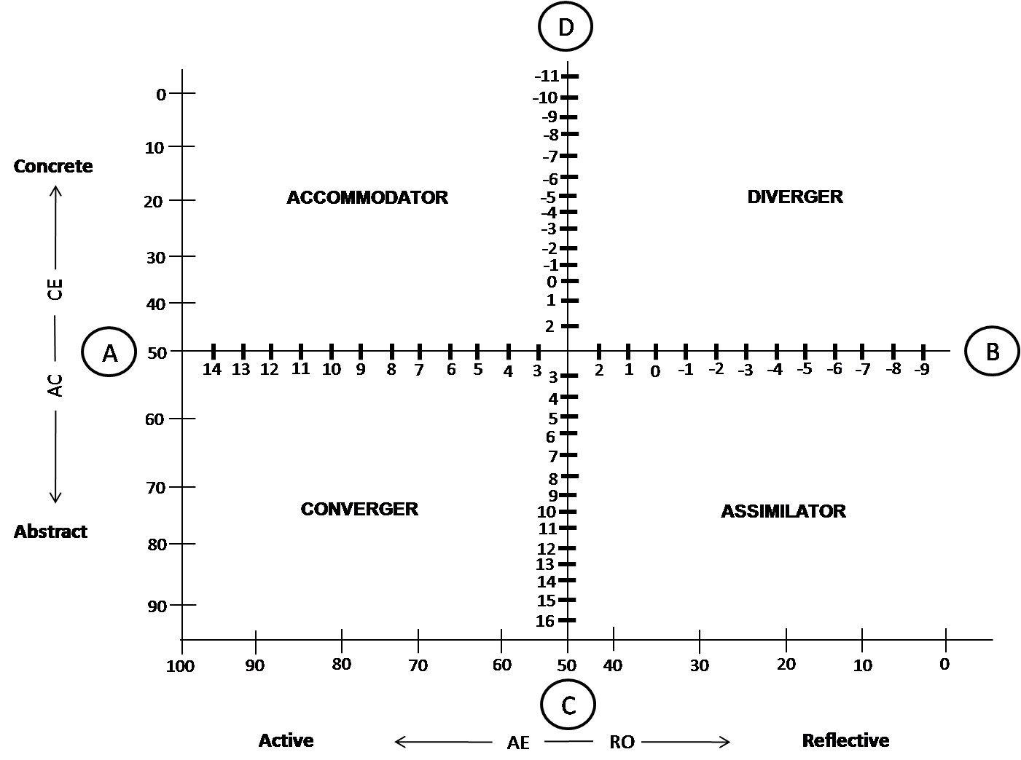
ACCOMMODATOR (“The Juggler”)

- Tick the statements that are true (for you) in each column
Strengths  - Gets totally involved in something that interests you  - Not concerned with making a fool of yourself or volunteering for something new  - Works well with other people, asks for help & talks through problems with others  - Learns by discussing issues with other people  - Enjoys writing freely  - Willing to experiment with any new/different idea or technique  - Takes risks  - Asks lots of questions  - Can work quickly  - Enthusiastic  - Likes variety and excitement  - Gets others involved  - Lots of energy  - Uses feelings well  - Will use all the senses: see it, hear it, feel it | Potential growth areas  - Not very thorough – can’t be bothered with details, research  - Doesn’t plan work in advance  - Doesn’t read through or check work  - Doesn’t rewrite notes or doesn’t file notes  - Rushes into exam questions & essays without thinking them through  - Neglects subjects that don’t interest you  - Not good at organizing time  - Tackles too many too many problems at once  - Doesn’t prioritise well  - Leaves things until last minute  - Poor critic of own ideas  - Can be demanding of friends  - Doesn’t stop to think it through  - Not so good at logical thinking  - Easily distracted

Accommodator (activist):
“Unlike the assimilators, accommodators will discard the theory if the facts do not fit. Accommodators excel in situations where they must apply theories to specific circumstances. Their greatest strength is their ability for getting things done and becoming fully involved in new experiences. Accommodators approach problems in an intuitive, trial-and-error manner and they obtain information from other people rather than through their own analytical abilities” (Stoot et al., 1998 p.2).
Accommodators are action-orientated and are bold risk-takers. They are great motivators. Because they get involved in many things, they may find it difficult to complete tasks. They have a wide range of interests and experiences. Should they lose interest in a task or subject, they simply move onto the next interesting task or. They need to learn to plan better; complete tasks and aim at depth and quality when doing assignments or committing to a task. They do not always realise their full potential because of their splintered approach to learning and task-completion.
DIVERGER (“The Bright Spark”)

- Tick the statements that are true (for you) in each column

Strengths  - Sees new ways of doing things/has creative solutions or new alternatives  - Sees long-term implications of things  - Good at seeing the ‘big picture’, see connections between different subjects being studied  - Listens to others & shares ideas  - Presents work in novel and artistically appealing ways  - Uses intuition  - Sees patterns from lots of different angles  - Pinpoints important new questions  - Uses daydreams well  - Can picture it, draw it  - Unhurried | Potential growth areas  - Forgets important details while understanding the ‘big picture’  - Waits too long before getting started  - Spends too much time on working out alternatives  - Doesn’t organize work well  - Doesn’t like work or revision timetables  - Tends to work in bursts of energy  - Easily distracted from the job at hand  - Not assertive enough with friends or teachers or in getting help  - You can’t see the ‘trees for the wood’ – forget important details, too easy going  - Often not critical of ideas  - Forgets to bring important books, etc., for homework  - Doesn’t rewrite or file notes  - Not so good at logical thinking and action plans  - Enjoys working with the problem sometimes rather than solving it

Divergers (reflector):
“The Diverger acquires knowledge through intuition. Individuals with this preferred style of learning draw upon their imaginative aptitude and their ability to view complex situations from many perspectives. Divergers also possess the ability to effectively integrate information into meaningful wholes. The Diverger’s imaginative ability is his/her greatest strength” (Stoot et al., 1998 p.2).
Divergers can multi-task but if they are not careful they can become too splintered in their task management. They are creative and do things differently each time. They are more comfortable with change than Convergers and Assimilators. Divergers are flexible, very visual, and like to tackle tasks in a tangible manner (hands-on). Theories and detail could bore them. They concentrate better when lecturers use diagrams, visuals and examples. Their greatest challenge is starting a project/task due to difficulties with decision-making.
CONVERGER (“The Sniper”)

- Tick the statements that are true (for you) in each column
Strengths  - Can work well alone  - Good at setting goals and making action plans  - Draws up timetables and can stick to it  - Follows revision timetables & work plans  - Organizes time well & have time for other things  - Gets things done on time  - Knows how to find the necessary information  - Reads instructions carefully  - Researches examination papers carefully  - Has notes classified & filed  - Pays attention to detail  - Wants to get results  - Can see the applications of a theory  - Does not get distracted | Potential growth areas  - Impatient with others’ viewpoints  - Often don’t work well with others  - Thinks there is only one way of doing something or solving a problem – your way  - Lacks imagination  - Not very interested in presentation of your work  - More concerned with getting the job done than with making sure it’s a really good job  - Gets preoccupied with details  - Cuts corners (takes short cuts)  - Fails to use friend, colleague & lecturer as resources  - Doesn’t use daydreaming or fantasy  - Poor at coming up with new questions  - Suspicious about feelings - their own and others  - Doesn’t like the ideas of others

Converger (pragmatist):
“The Converger acquires knowledge by thinking/analysing and then practically applying the new ideas and concepts. The ability to apply ideas is this learner’s greatest strength. Convergers organise information through hypothetical deductive reasoning” (Stoot et al., 1998 p.2).

Convergers tend to be in the minority. They are self-reliant and generally do not like group-work because they feel that they have arrived at the answer already. They tend to be independent in many ways; not relying on others much, as a result they rarely ask for help. They do not really want to talk about their feelings. Their strengths are that they tend to master time, meet deadlines and follow schedules well. Convergers are result-orientated: they produce. A growth area that they usually need to focus on is interpersonal relationships.

ASSIMILATOR (“The Googler”)

- Tick the statements that are true (for you) in each column

Strengths  - Likes to understand everything you are working on  - Curious & enjoys problems  - Works well alone with minimum help from lecturers, colleagues & friends  - Plans well in advance for essays & exams  - Good at making lists, timetables & plans  - Can organize facts & material well  - Can set clear goals, know why you are doing something & which topic is top priority  - Can reason it out step by step  - Pays attention to detail  - Sticks with one problem at a time  - Can see the links between ideas  - Works things out well on paper  - Precise & thorough  - Reworks essays and notes  - A good critic of own ideas | Potential areas of growth  - Needs too much information before getting down to work and allowing yourself an opinion  - Reluctant to try new approaches or suspicious of new techniques  - Likes to do things in a set way – not creative  - Does not function very well in group discussions  - Only trust logic  - Overcautious, don’t like taking risks or trying ‘silly’ ideas  - Doesn’t use other people enough  - Doesn’t trust intuition enough  - Can collect too much information  - Likes to follow a set way  - Fails to use lecturers, colleagues & friends as resources  - Can get bogged down in theory and detail  - Does not trust feeling (your own or others)  - Keep problems to yourself

Assimilator (theorist):
“The ability to create theoretical models and reason inductively is the assimilator’s greatest strength. Assimilators learn by thinking and analyzing and then planning and reflecting. Assimilators do not emphasize practical application; rather they focus on the development of theories, often discarding facts if they do not fit theory” (Stott, McDermott, Green & Francis, 1988 p.2).
Assimilators tend to need a lot of time to prepare and think through ideas. Because they spend much time understanding and absorbing/assimilating material, they tend to remember very well. They need time to weigh up all the options and make an informed decision – this in turn makes it difficult for them to change their minds very quickly. Their value in a group is their ability to demand depth and thoroughness. A challenge for them is planning and task completion. They need to learn to multi-task when necessary – this is something that does not come naturally to them.

