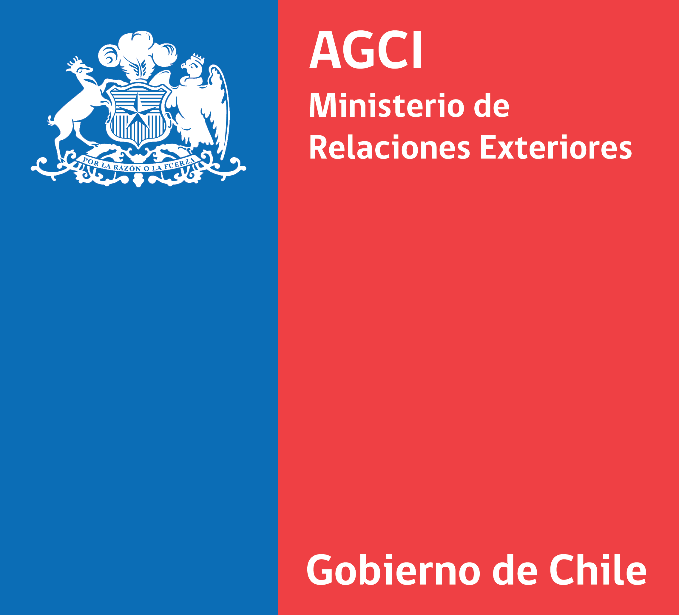

CHILEAN INTERNATIONAL COOPERATION AGENCY
HORIZONTAL COOPERATION SCHOLARSHIP PROGRAM
NELSON MANDELA
CALL FOR APPLICATIONS 2016

AGOSTO 2015
CHILEAN INTERNATIONAL COOPERATION AGENCY
HORIZONTAL COOPERATION SCHOLARSHIP PROGRAM
NELSON MANDELA
CALL FOR APPLICATIONS 2016

INDEX.

A. IntroducTION. 3
B. PROGRAM OBJECTIVES. 3
C. SCHOLARSHIP CHARACTERISTICS. 3
D. Application Process. 5
E. SELECTION PROCESS. 6
G. COMMITMENTS TO BE ASSUMED BY THE SELECTED APPLICANTS. 9
H. SCHOLARSHIP RECIPIENT’S COMMITMENTS. 10
I. CASES IN WHICH AGCI MAY SUSPEND THE SCHOLARSHIP BENEFITS OR APPLY THE RETENTION OF THE MONTHLY ALLOWANCE. 12
J. EARLY TERMINATION OF THE SCHOLARSHIP FOR REASONS ATTRIBUTABLE TO THE SCHOLARSHIP RECIPIENT 12
K. OTHER ISSUES. 12
L. ADDITIONAL INFORMATION. 13
M. ANNEXES. 13

A. IntroducTION.

From the academic year 2016 onwards, the Chilean International Cooperation Agency (AGCI) offers, scholarships to perform Master Studies in accredited universities or other institutions of higher education in Chile. These scholarships are offered to professionals who are nationals of South Africa, Mozambique or Angola.

The Horizontal Cooperation Scholarship Program AGCI began in 1993, and to date, more than 800 professionals from Latin America and the Caribbean have completed graduate programs in various areas of specialization offered by Chilean universities or institutions of higher education in our country.

B. PROGRAM OBJECTIVES.

The purpose of the AGCI Scholarship Program is to contribute to the formation of advanced human capital, through the participation of professionals in Master programs taught by accredited higher education institutions with a high level of excellence in Chile,.

C. SCHOLARSHIP CHARACTERISTICS.

Scholarships are awarded for a maximum duration of 24 months, depending on the length of the chosen program of study.

This Scholarship includes an Introductory Spanish course, which will be starting on March 2016, in order the Master Programme can start in the same month. The Spanish course and the Master Programme shall be taken along simultaneously. The student also can begin the Master Programme and the Spanish course on August 10th, 2016 according to the academic schedules or programmes already established by the Chilean University or Institution that the students have been accepted.

Scholarships may only be granted to pursue Master studies referred to in Annex 1 of this Call.

The studies are undertaken in an exclusive dedication regime, full-time, and with mandatory attendance. The applicant has to remain in Chile throughout the entire program of study.

Selected scholarship holders must provide a certification of proficiency in Spanish, since the outlined courses will be taught in Spanish only.

There will be the following priority criteria for granting scholarships:

- Applications submitted by public servants or academics from universities officially recognized by the respective country.

- Candidates who are mentioned in the Annex 1, Master Accredited Programs.

- Applications in the areas of ASTRONOMY, AGRICULTURE, ENERGY, PUBLIC POLICY MANAGEMENT, HEALTH, ENVIRONMENT AND MINING.

The scholarship comprises the following benefits;

- An Introductory Spanish course that can last from 3 up to 6 months, before the master programme begins. (Those candidates who can prove Spanish proficiency will be exempt to take this course).

- Round trip tickets. Departing from capital of the student´s country to Santiago de Chile, and returning the country of origin once the studies are fully completed. (The student must hold a personal budget to stay in the Capital Of Santiago to complete the procedures and formalities required, this action requires no more than three days for staying, food and personal expenses)
- Payment of fees, registration and degree costs charged by the respective institution of higher education, for the duration of the postgraduate program, with a maximum of four academic semesters, or six academic quarters, depending on the schedule used by the respective institution. In any case, this expense is only covered for the academic curriculum of the program of study for which the scholarship is granted.
- Payment of a maintenance allowance of four hundred and sixty thousand Chilean pesos ($ 460.000) throughout the period of the scholarship. This allowance will be paid throughout the duration of the program, with a maximum of twenty-four (24) months.
In the months of December, January and/or February, AGCI will pay 100% of the monthly allowance to the scholarship recipient only if he/she remains in Chile for more than half of the respective month. In any other case, AGCI will pay only 50% of the monthly allowance.
- Provision of life, health and accident insurance to the scholarship holder, while the scholarship is in force for events or claims that affect and occur within the territory of Chile.
- Awarding the scholarship recipient with a single allocation for textbooks and study materials up to ninety thousand Chilean pesos ($ 90,000) within their first semester of the study program.

- Granting the scholarship recipient, one-time and provided their grade point average in the respective study program is equal to or higher than 5.5 (five point five) or its equivalent level, an allocation equivalent to half of the monthly allowance to support thesis expenses or to comply with the requirements of the higher education institution to provide the respective degree. For this purpose, the scholarship recipient must prove the compliance with all aspects raised in paragraph V of the third clause of the Convention whose format is attached in Annex 2 of this Call, before the expiration of the nineteenth month in which AGCI pays the monthly allowance stated in point III of this section.
In case of theses related to areas proposed for each country, scholarship recipients may possibly participate in the development of the respective project if so required by AGCI.

The aforementioned benefits are exclusively for the scholarship recipient.

AGCI does not pay any expense that is not covered by the above list. It is therefore the responsibility of the scholarship recipient to finance any other expenses to be incurred in respect of procedures for visa application, fees to institutions of Chilean higher education, travel fees and related costs, or travels to his country throughout the duration of the scholarship, etc.

No applicants will be accepted whose spouse is beneficiary of these benefits or applies in the same call for applications.

These scholarships are incompatible with any other that the beneficiary could have in Chile.

Scholarships will only be awarded for studies in Chile.

In case the evaluation in accordance to the procedures and weights indicated in paragraph F of this Call, leads to equal scores between two or more applications for the scholarship, preference will be given to those programs whose classes begin in the first half of 2016.

D. Application Process.

The documents to apply for the scholarships must be submitted to the EMBASSY OF CHILE IN SOUTH AFRICA (see Annex 3, listing attached).

Those interested in scholarships of this call must directly arrange for the admission in the respective study program at the university or other institution of Chilean higher education of their choice, and must receive the unconditional acceptance of it in order to start their application. Programs must run under exclusive dedication regime and full time. If there is a program with different features, it will not be considered in the selection process.

Every interested person should make inquiries regarding the orientation and curriculum of the Master of his Interest. We suggest to take direct contact with the responsible person for the admission process of the Chilean Universities or institutes of higher education and to ask in written form for all the details regarding the study program (requirements, expected skills, focus of the program etc.)

The Embassy of Chile may interview the candidates, if deemed appropriate.

Applicants must submit the following documents both on paper and on a compact disc (CD) (with the related information scanned when applicable):

- Scholarship Application Form to AGCI, duly completed and signed, as indicated in Annex 4.

- Final acceptance letter of the Study Program chosen, issued by the competent authority of the Chilean higher education institution. This letter should demonstrate unconditional acceptance of the applicant, the starting date of classes and the duration of the program of study, including the thesis and degree examination.

- Compatible health certificate issued and signed by a licensed doctor, indicating preexisting conditions declared by the applicant. For this purpose, please find attached as Annex 6 a recommendation of a Health Declaration.

- University certificate or certified copy thereof.

- Curriculum Vitae, with emphasis on both work and academic history.

- Brief description of the applicant’s reasons to study in Chile, the objectives of the studies desired and how the applicant intends to implement them back at home.

- Brief description of the possible area and topic of the thesis on which the applicant wants to focus his/her final research.

- Academic reference letter.

- Letter of sponsorship from the employing institution, which clearly specifies their interest in having their employee or official conducting studies in Chile and the indication that the person actually has permission to be absent during the duration of the scholarship and if they will keep or not his/her position back home.

The originals will be returned later by the Embassy of Chile to the applicant.

This procedure will be used, if applicable, to those foreign applicants who are already studying in Chile.

All documentation above should be directed at the International Cooperation Agency of Chile, through the Embassy of Chile in South Africa by diplomatic bag. Original documents must remain in power of the applicants and will be required only once the applicants arrive to Chile. This measure has been established to expedite the selection process in Chile.

The remittance of the information to AGCI by the Embassy of Chile will be understood as accreditation that the applicant has complied with the requirements of the interested party.

The no receipt of the complete documentation required by this call or the entry of false documentation will be causal for immediate removal of the final selection process.

E. SELECTION PROCESS.

The selection process includes the following steps:

- Preselection. This stage will be carried out in the country which represents the applicant and should be conducted by a joint screening Committee consisting of a Focal Point or his representative, and the official designated by the Embassy of Chile in South Africa, who will act in accordance with eminently technical criteria. This preselection will feature candidates officially presented by the country. It is important that in this process the respective Focal Point selects the best candidates, since the submitting postulants must compete for available spaces with shortlisted candidates of the other participating countries. The Embassy of Chile in South Africa will send the information via diplomatic bag.

- Final selection. This stage will performed by the Selection Committee of the Program in Chile.
Only candidates who fulfill all the requirements and provide full documentation will be considered by the Selection Committee in Chile, which will decide on the candidates final acceptance for the scholarship. The decision of the Selection Committee is not subject to appeal and will be officially informed of both stakeholders and the authorities of the focal point of the country, the Ambassador of Chile in the committed country and its ambassador in Chile.

The acceptance of the scholarship by the scholarship recipient is implemented through the signing of an agreement between AGCI and the selected candidate. The draft format is attached in Annex 2 of this call. The referral form may be adapted to the case of each student and in particular to every study program and their duration.

The deadline for accepting applications in the Embassy of Chile in South Africa must be duly verified by the applicant.

The deadline for registering the candidate’s information that will be shortlisted by the Embassy of Chile in South Africa, by diplomatic bag, ends officially on: Friday, January 8th 2016.

Applications sent by the Embassy of Chile in South Africa and received after the above deadline will automatically not be considered.

The results of the final selection will be communicated from the last week of January 2016.

F. SELECTION CRITERIA.
In order to select the scholarship recipients, AGCI applies the following evaluation criteria to those factors that qualify applicants and are susceptible of quantification:

1. Priority Assigned by the Application Country: Each country must indicate the priority of the candidates shortlisted on a continuous descending order, from first priority to the last according to the total number of preselected (for example, if the total number of pre-selected is 5, the priorities go from the first to the fifth).

- First priority: 30 points.
- Second priority: 25 points.
- Third priority: 20 points.
- Fourth priority: 15 points.
- Fifth priority: 10 points.
- Sixth priority: 5 points.

Weight: 0.20 (20.0 percent).

2. Work Experience - Professional: This criterion is expressed in years of professional experience in the field of the program of study for which the candidate applies.

- More than 5 years: 30 Points.
- More than 3 years and less than 5 years: 20 Points.
- Less than 3 years: 10 Points.
- Recent graduates: 5 Points.

Weight: 0.10 (10.0 percent)

3. Institution in which the applicant works at the time of application: This criterion will be measured based on the institution that supports the candidate’s application.

- Public Institution: 30 points. (Professionals with higher education degrees who work in an public office in the Government from their nationality such as ministries, services, institutions and public companies, or academics, teachers and researchers in higher education institutions officially recognized by the State submitting the candidate’s application).
- Private Institution: 10 points. (Professionals working in various fields of civil society in their country at the time of their application).
- No Job: 0 points.

Weight: 0.10 (10.0 percent)

4. Gender: This is to promote women's participation in the Advanced Human formation training programs granted by AGCI.

- Nominations of Women: 30 Points.
- Nominations of Men: 15 Points.

Weight: 0.10 (10.0 percent)

5. Age: Criteria agreed at earlier Selection Committees
- Between 30 and 35 years: 40 Points.
- Between 36 y 44 years: 30 Points.
- Between de 29 years: 20 Points.
- More than 45 years: 10 Points.

Weight: 0.05 (05.0 percent)

6. Regional Criteria: This to encourage applications to universities in Chilean regions, who have specialized areas.

- Application to a University in a different region than the metropolitan region: 30 Points.
- Application to a University in the metropolitan region (Santiago): 15 Points.

Weight: 0.05 (05.0 percent)

TOTAL: 60%.

7. Score Selection Committee: The Selection Committee will review the aforementioned quantifiable factors and, as a result of that analysis, make an overview of all the antecedents of the applicant. This approach provides the space to include the priorities of the Cooperation and Foreign Policy, which will materialize in any of the following qualifications:

- Excellent: 30 Points.
- Very good: 25 points.
- Good: 20 Points.
- Acceptable: 15 Points.

If an application is marked with a grade lower than "Acceptable", it will be automatically discarded, regardless of the score they obtained on quantifiable factors.

Weight: 0.40 (40.0 percent)
TOTAL: 100%.

G. COMMITMENTS TO BE ASSUMED BY THE SELECTED APPLICANTS.

Candidates selected for a scholarship from AGCI have to:

- Travel to Chile, or be in Chile, sufficiently in advance of the start date of the respective study program (3 to 5 days in advance are suggested).

- Obtain, in advance, the permission of the employing entity.

- Get with due anticipation the residence permit in Chile.

IV. Subscribe the Affidavit included in the final part of this chapter and send a scanned copy of it to the email address: fcontreras@agci.cl.

V. Submit, in person at the offices of AGCI, the originals of the documents mentioned in items 2, 3, and 9 of point D of this Call and of the Affidavit alluded to in the previous paragraph.

VI. Subscribe the scholarship acceptance agreement in Chile, which preliminary format can be found in Annex 2 of this call. In any case, AGCI will forward the agreement text in advance, by email, to the selected candidate, which will be adapted to the particular case of each applicant.

The text of the affidavit referred to in item IV is attached as Annex 5 of this call.

H. SCHOLARSHIP RECIPIENT’S COMMITMENTS.

Each scholarship holder assumes the following commitments:

- To be in possession of the grades or academic certificates as well as of the academic curriculum requirements and other qualifications required by the higher education institution to which he/she has been accepted.

- To accredit, by competent medical certificate, whenever it is requested by AGCI, good physical and mental health, consistent with the academic demands of the studies for which the scholarship has been granted. We suggest to use format specified in Annex 6.

- To comply with immigration regulations in force in Chile.

- To establish domicile in the city in which the program of study for which the scholarship has been granted will be taken, within three business days following the date of signature of this agreement. The grantee should report this address to AGCI immediately, as well as any changes occurred. Also, he/she must keep AGCI informed about their phone numbers in Chile as well as his/her current email address.

- To reside in the locality in which the courses of the program of study for which the scholarship has been awarded take place, while the scholarship is in effect.

- To not leave Chile without the consent of AGCI while the scholarship is in effect. In order to accredit the due fulfillment of the outlined obligations, AGCI is authorized to request the scholarship recipient’s passport and to ask the relevant Chilean immigration authority for certifications regarding the entries and exits of the grantee from the Chilean territory.

The scholarship recipient may only leave the country with AGCI’s prior authorization in the following cases:

I) During the months of December, January and February each year and only for the period referred to the academic holiday stated in the study program. For these purposes, the grantee must submit his/her application along with the document issued by the University, which establishes the precise holiday period of the respective academic program.

II) For a brief period, which should not exceed five working days. Only in extraordinary cases, and duly justified by the grantee, AGCI may grant a longer period.

For this purpose, the scholarship recipient must submit a written application to AGCI not later than five business days prior to the scheduled date for the trip. In an event of force majeure cases, understood as those described in paragraph 1 of the sixth clause of this agreement, AGCI may allow the filing of such application with less anticipation. Once the scholarship holder returns to Chile, he must immediately report this to AGCI.

- To display an irreproachable behavior in full compliance with Chilean laws. Notwithstanding any other facts that may involve a breach of this obligation, it will be understood as unfulfilled whenever the grantee is formalized by crime or offense.

- To provide, within the time set by AGCI, all the necessary information.

- To meet the academic regime established by the institution of higher education in which the studies will be taken.

- To approve all the courses or lectures that, under the respective program of study, the applicant will take during each applicable semester.

- To have, in each semester, a good academic performance defined as a grade point average equal to or higher than 5.0, or its equivalent scale.

- To meet the academic and administrative requirements of the respective institution of higher education to obtain the academic degree of the program of study for which the scholarship has been granted. To demonstrate compliance with this requirement, the grantee should submit to AGCI the certificates issued by the competent academic authority of the respective institution of higher education, for:
I. Compliance with the above requirements, and
  - The score or the final grade (expressed on a scale of 1 to 7, in which the latter is the maximum) obtained in the respective study program.

- To exclusively commit to the studies for which the scholarship has been awarded, while it is in effect. The fulfillment of this obligation includes the prohibition to perform paid work in Chile or outside the country.

- To comply on time with any written requests formulated by AGCI, including responding to surveys indicated by the Agency, and to attend any assembly or meeting to be convened in writing by the Agency during the period of the grant.

- To deliver to AGCI, at the end of the studies, in compact disc (cd) a copy of the final text of the thesis or a similar monograph prepared by the grantee in the course of the program of study. The thesis should preferably fit within the subject areas offered to each country.

- To register as an AGCI scholarship holder for every research and dissemination activity with an academic profile in which he/she participates.

- To not apply for scholarships that fully or partially coincide with those which are currently pursued thanks to the benefits from AGCI, as long as the participant has the quality of scholarship recipient from the agency.

- To return to their country after having completed the entire study program for which the scholarship was awarded.

- To sign an agreement with AGCI that regulates the scholarship, and faithfully fulfills the commitments outlined in this chapter.

I. CASES IN WHICH AGCI MAY SUSPEND THE SCHOLARSHIP BENEFITS OR APPLY THE RETENTION OF THE MONTHLY ALLOWANCE.

In the event a grantee fails to comply with the commitments set out in the preceding chapter of this call, AGCI may apply one of the measures outlined in the fifth clause of the contract whose format is attached in Annex 2.

J. EARLY TERMINATION OF THE SCHOLARSHIP FOR REASONS ATTRIBUTABLE TO THE SCHOLARSHIP RECIPIENT

If the scholarship recipient infringes upon any of the conditions outlined in items 2 and 3 of the sixth clause of the agreement, whose format is attached in Annex 2, AGCI may terminate the respective scholarship before maturity and hence all the benefits outlined in point C of this call.

The scholarship recipient who is subject to the aforementioned measure of early termination of the scholarship may not apply again for a scholarship from AGCI. The same applies for persons who violate the commitment contained in No. 18 of the fourth clause of the agreement.

In case of an early termination of the scholarship as outlined above, the respective scholarship recipient will have to return the totality of the expenses that AGCI has incurred related to this grantee in terms of the benefits outlined in points I, II, IV and V of the third clause of the agreement which format is attached as annex 2 of this call for applications. To this effect, AGCI will notify the scholarship recipient as well as the focal point of the Agency in the country of his/her nationality in writing, indicating the sum which has to be returned as well as the related details.

K. OTHER ISSUES.

Anyone who has been granted a scholarship from the Chilean Cooperation Agency will be unable to apply for another scholarship for a period of five years after the end of the original one, if the new scholarship aims at postgraduate development. In case the new grant is related to a specialized development of short duration, applications are allowed after a period of three years after the end of the original grant.

L. ADDITIONAL INFORMATION.

Information from AGCI: By fax: (56) - (2) -28275794. By E-Mail: agencia@agci.cl. Access to AGCI´s Website on the INTERNET: http://www.agci.gob.cl or http://www.agci.cl.

Interested parties are advised to consult preferably on the homepage or to communicate by E-Mail.

AGCI’s address is Teatinos 180, 8th Floor. Santiago. Chile. Phone no. (56)-(2)-28275733 or 28275842.

You can also access the AGCI’s website via:

- Http://www.estoeschile.cl
- http://www.chileclic.cl
- http://www.gobiernodechile.cl

Information related to the Scholarship Program: Applicants who are interested in having more information than the one contained in this call can refer to:

- The Focal Point of the country.
- The Embassy of Chile in the respective country.
- The Embassy of the country in Chile.
- AGCI, via the means indicated above.

M. ANNEXES.

- ANNEX 1: List of Master Programs Accredited by the National Accreditation Board

- ANNEX 2: Preliminary format of the scholarship acceptance agreement that regulates the relationship between AGCI and the scholarship holder.

- ANNEX 3: Focal Points of the invited countries.

- ANNEX 4: Scholarship Application Form.

- ANNEX 5: Affidavit to be filed by the selected candidates, according to the final paragraph of Chapter G of this call.

- ANNEX 6: Recommended health declaration form.

